**Modeling and Implementation of a DC microgrid Energy Management System**

By

**Fannie Masango**

Submitted in partial fulfilment of the requirement for the degree

**Master of Engineering in Electrical Engineering**

In the

Department of Electrical Engineering

FACULTY OF ENGINEERING AND THE BUILT ENVIRONMENT,

**Tshwane University of Technology**

Supervisor: Prof. J.A. Jordaan

Co-Supervisor: Dr A F Nnachi

July 2024

# Declaration

I hereby declare that the dissertation submitted for the degree M Eng: Electrical Engineering, at Tshwane University of Technology, is my own original work and has not previously been submitted to any other institution of higher education. I further declare that all sources cited or quoted are indicated by means of comprehensive list of references.

F. I. Masango

Copyright© Tshwane University of Technology

# Acknowledgement

I wish to convey my heartfelt appreciation to Prof. JA Jordaan, my supervisor, for his positive outlook and invaluable guidance, as well as to Dr. AF Nnachi, my co-supervisor, for his mentorship, patience, and expertise. Under your supervision, I have gained immeasurable insights and knowledge.

**To My Teachers:**

I would like to express my gratitude to the faculty members at Tshwane University of Technology, eMalahleni campus, with special recognition for Mr. P Ehlers, Dr. CG Richards, Mr. Manana, Dr. AO Akumu and Dr. PF LeRoux. Their unwavering commitment to nurturing my academic development and sparking my intellectual curiosity is greatly appreciated.

For all those whose names I may have omitted but who have played a part in my academic journey, I express my heartfelt gratitude.

This dissertation is a testament to the collective efforts and encouragement of all these individuals and entities. Your belief in me has been a driving force behind my accomplishments, and I am profoundly grateful for your unwavering support.

FI Masango

# Abstract

Microgrids (MG) are small-scale power subsystems that incorporate distributed generation, energy storage, local loads, system control, and coordination. Energy Management Systems (EMSs) play a crucial role in fortifying the resilience of microgrids, ensuring their stability and continued operation even when energy supply is constrained. An EMS enables centralized monitoring and control of energy consumption across various building systems. It is designed to collect, store, and analyze power consumption data from residential and industrial appliances.

To achieve a fully automated and stable grid with plug-and-play capabilities, an agent-based EMS is proposed for use in a DC microgrid. This dissertation introduces an energy management system utilizing a system of systems (SoSs) approach. A model and simulation of an energy management system for a PV/Composite Storage DC microgrid are developed in MATLAB. The primary aim of this dissertation is to enhance the performance of the DC Microgrid by integrating an existing grid with an energy management system at the residential level. The control system's objective is to ensure prolonged operation of loads by maintaining the local battery's charge until the PV modules cease power generation. Four scenarios of varying load demand were tested. The results obtained from both scenarios demonstrate the effectiveness of this control system design approach.

In addition to digital simulations, a physical representation of the DC Microgrid (DC MG) has been constructed to validate the simulations in real-life scenarios. This physical system allows for hands-on analysis and experimentation, facilitating a deeper understanding of the data generated during the simulation phase. The combination of digital simulations and physical experimentation ensures a comprehensive and reliable assessment of the DC microgrid's behavior and performance under various conditions.

Results indicate that non-EMS integrated DC microgrids can fulfill energy demands more directly, while EMS-integrated systems prioritise battery charging, resulting in a 10% improvement in the state of charge of local storage. However, this feature may prevent the system from fully meeting immediate load demand. During periods of peak load, both systems experience similar SoC declines, but the EMS's energy-saving features extend battery life by reducing supply capacity when the SoC falls below a critical threshold. Despite some limitations in meeting high demand due to restricted battery capacity, the EMS enhances battery lifespan by preventing excessive discharge and improves overall grid stability. These findings suggest that a strategic balance between local and storage usage and grid reliance can be achieved without a central control element by using a system-of-systems approach.

Table of Contents

Declaration ii

Acknowledgement iii

Abstract iv

List of tables viii

List of figures ix

Nomenclature xi

Chapter 1 13

1 INTRODUCTION 13

1.1 Background to the research problem 13

1.2 Statement of research problem 13

1.3 Objectives of the research problem 15

1.4 Delimitation of study 15

1.5 Research Methodology 15

1.5.1. Research Design 16

1.5.2. Component technology. 17

1.5.3. Simulation and optimisation 17

1.5.4. Implementation 18

1.6 Layout of dissertation 18

Chapter 2 20

2 LITERATURE REVIEW 20

2.1 Introduction 20

2.2 The Shift from AC to Decentralised DC Microgrids. 20

2.3 DC Generation Technologies 21

2.3.1. Photovoltaic Panel 21

2.3.2. Thermoelectric generators (TEGs) 23

2.3.3. Wind Turbine 23

2.4 DC Distribution 23

2.5 Energy Storage Technologies. 25

2.5.1. Electromechanical Storage 26

2.5.2. Hydrogen Energy Storage (HES) 26

2.5.3. Mechanical Storage 26

2.5.4. Super Capacitor Energy Storage (SES) 26

2.5.5. Thermal Energy Storage (TES) 27

2.6 Microgrid types 27

2.7 Operational Strategies for DC Microgrids 27

2.7.1. Constant-current control 28

2.7.2. Constant-voltage control 28

2.7.3. Droop control 28

2.7.4. DC Voltage standards 29

2.8 EMS-integrated DC MG 29

2.8.1. Multi-level approach 29

2.9 Proposed study 30

2.9.1. Systems of Systems (SoSs) 31

2.9.2. Modelling the microgrid for the EMS using SoSs 31

2.10 Proposed study 32

Chapter 3 33

3 THEORETICAL CONSIDERATIONS 33

3.1 Introduction 33

3.2 Feasibility study and planning 33

3.3 Resource Assessment and Design 34

3.3.1. Battery Energy Storage System 34

3.3.2. Power Balancing and Control 34

3.3.3. Energy Management System 35

3.4 Conclusion 39

Chapter 4 40

4 METHODS AND MATERIALS 40

4.1 Introduction 40

4.2 Microgrid configuration 40

4.3 Scenarios for diverse inputs 41

4.4 Matlab Simulink Model 41

4.5 Validation and Verification 41

4.6 Microgrid Formation 42

4.6.1. Photo Voltaic Solar Panels 42

4.6.2. Battery Storage Capacity 43

4.6.3. Load Profile 44

4.7 REMCS Design Logic 48

4.7.1. State Observer 48

4.8 Model parameters 51

4.8.1. Case study 1 53

4.8.2. Case Study 2 56

4.8.3. Case Study 3 61

4.8.4. Case Study 4 64

4.9 Lab-Developed Working System Setup 65

4.9.1. Lab results - Unit 1 66

4.9.2. Lab results - Unit 2 68

4.9.3. Lab results - Unit 3 70

4.9.4. Lab results - Unit 4 71

Chapter 5 73

5 CONCLUSION AND RECOMMENDATIONS 73

5.1 Key findings: 73

4.9.5. Efficiency in Energy Utilisation 73

4.9.6. Power Sharing 73

4.9.7. Grid Dependence and Battery Capacity 74

4.9.8. Comparative analysis of Supply and Demand 74

# List of tables

Table 2.1 Types of energy storage 25

Table 2.2: Systems of Systems characteristics 31

Table 4.1: PV array parameters 42

Table 4.2: Energy storage parameters 43

Table 4.3:Scenario 1: Model setup parameters 52

Table 4.4 Scenario 2: Model setup parameters 56

Table 4.5: Scenario 3: Model setup parameters 61

Table 4.6: Scenario 4: Model setup parameters 64

Table 4.7: Unit1 - Laboratory setup parameters 66

Table 4.8 : Unit2 - Laboratory setup parameters 68

Table 4.9 : Unit3 - Laboratory setup parameters 70

Table 4.10 Unit 4 - Laboratory setup parameters 71

# List of figures

Figure 1.1 DC nano grid 14

Figure 1.2 Residential unit operation modes. 17

Figure 2.1 A Matlab/Simulink model of a PV cell 22

Figure 2.2: Uni polar grid 24

Figure 2.3 Bi-polar grid 24

Figure 2.4 DC voltage-current characteristic line 28

Figure 2.5 Centralised multi-agent coordination 30

Figure 2.6: De-centralized multi-agent co-ordination 30

Figure 2.7: DC MG Systems of Systems 32

Figure 3.1: Operating mode 1 strategy 36

Figure 3.2: Operating mode 2 strategy 37

Figure 3.3: Operating mode 3 strategy 38

Figure 3.4: Operating mode 4 strategy. 38

Figure 4.1 Residential unit operation modes with solar farm 40

Figure 4.2: Photo Voltaic Generation Irradiance and Temperature 8/16/2020 [42] 43

Figure 4.3: Battery Storage System 44

Figure 4.4: Load demand: Profile 1 44

Figure 4.5: Load demand: Profile 2 45

Figure 4.6 Load demand: Profile 4 45

Figure 4.7: Load demand: Profile 3 45

Figure 4.8 Load profile waveform selector 46

Figure 4.9 REMCS unit Matlab overview 46

Figure 4.10: REMCS nano grid 47

Figure 4.11: Loads control circuit 47

Figure 4.12: load demand block 48

Figure 4.13: State chart block 49

Figure 4.14: Running on battery. 50

Figure 4.15: Battery Charging State 50

Figure 4.16: Power Sharing 51

Figure 4.17: non-EMS Supply capacity with v load demand 53

Figure 4.18: Supply capacity with EMS v load demand 53

Figure 4.19: Local Storage SoC EMS v non-EMS system 54

Figure 4.20: Solar Farm Storage SoC EMS v non-EMS system 55

Figure 4.21:Non-EMS Supply capacity v Load demand 55

Figure 4.22: Supply capacity EMS v Load demand 55

Figure 4.23: Solar Farm Storage SoC EMS v non-EMS 56

Figure 4.24: Local Storage SoC EMS v non-EMS 56

Figure 4.25: Non-EMS Supply capacity v load demand 57

Figure 4.26: EMS Supply capacity v load demand 57

Figure 4.27: Solar Farm SoC EMS v non-EMS 58

Figure 4.28: local SoC and state transition 59

Figure 4.29: Non-EMS Supply capacity v load demand 59

Figure 4.30: EMS Supply capacity v load demand 59

Figure 4.31: Solar Farm SoC EMS v non-EMS 60

Figure 4.32:EMS supply capacity and state transition 60

Figure 4.33: Non-EMS Supply capacity v load demand 61

Figure 4.34: EMS Supply capacity v load demand 61

Figure 4.35: Local storage SoC EMS v non-EMS 62

Figure 4.36: Non-EMS Supply capacity v load demand 63

Figure 4.37: EMS Supply capacity v load demand 63

Figure 4.38: Solar Farm SoC EMS v non-EMS 63

Figure 4.39: Local storage SoC EMS v non-EMS 63

Figure 4.40: non-EMS Supply capacity v load demand 65

Figure 4.41: EMS Supply capacity v load demand 65

Figure 4.42: Lab setup of four units DC microgrid 66

Figure 4.43: Unit 1 5-day Supply v Load Demand 67

Figure 4.44: five-day Solar farm SoC v Operation state. 68

Figure 4.45 Unit 2 Supply Capacity v Load Demand. 69

Figure 4.46 Unit 2 Solar Farm v local storage SoC. 70

Figure 4.47 Unit 3 Supply Capacity v Load Demand. 71

Figure 4.48 Unit 4 Supply Capacity v Load Demand. 72

# Nomenclature

|  |  |  |
| --- | --- | --- |
| AC | - | Alternative Current |
| AFE | - | Active Front End |
| AI | - | Artificial Intelligence |
| CGMS | - | Central Grid Management System |
| DC | - | Direct Current |
| DCMG | - | Direct Current Microgrid |
| DER | - | Distributed Energy Resources |
| EMS | - | Energy Management System |
| ER | - | Energy Resources |
| ESS | - | Energy Storage System |
| MG | - | Microgrid |
| MPPT | - | Maximum Power Point Tracker |
| PD | - | Power Delivery |
| REMCS | - | Residential Energy Management and Control System |
| RES | - | Renewable Energy resources |
| SoC | - | State of Charge |
| SoS | - | System of Systems |
| USB | - | Universal Serial Bus |

Chapter 1

# INTRODUCTION

## Background to the research problem

The intermittency of Renewable Energy Sources poses a significant challenge in standalone DC Microgrids (DCMGs). Additionally, variations in load, changes in generating and storage capacities, and unstable bus voltages further complicate microgrid stability. DCMGs are characterized by power-sharing, where Energy Resources (ERs) are distributed across the grid and connected via a bus line. DC-DC converters are essential components, adjusting source voltages to match the bus voltage.

In residential distribution systems (RDSs), such as those using DERs like PV panels, load demand varies considerably based on usage, necessitating generation and load forecasting to manage these fluctuations effectively. The intermittency of RES adds complexity, making it challenging to manage constant load removal, power supply, and the balance between power production and demand. Hence, there's a clear need for a robust Energy Management System (EMS).

An EMS offers centralised monitoring and control of energy usage across building systems, capable of recording, storing, and processing power consumption data from major household and industrial appliances. This research proposes an agent-based energy management system, which, when employed in a DC microgrid, can achieve a fully automated and stable grid with plug-and-play capabilities. Hierarchical control in a DC microgrid enhances grid efficiency by introducing load-shedding and minimizing downtime.

## Statement of research problem

The adoption of renewable energy resources (RES) is increasing as many countries work to move away from non-renewable energy sources due to their role in contributing to atmospheric carbon emissions. Microgrids, which integrate distributed energy resources (DERs), energy storage systems, and load management, are being employed to electrify off-grid rural villages and remote areas. DC Microgrids (DCMGs) are widely used in various sectors, including aerospace, automotive, and marine industries. They are essential for integrating DERs, particularly because most renewable energy sources produce DC power. Conversely, a nano grid is designed to distribute power within a single house or small building. A typical DC nano grid includes DERs, Maximum Power Point Tracking (MPPT) systems, and an Energy Storage System (ESS). A microgrid combines distributed energy resources, energy storage, and load. They have been used in the electrification of off-grid rural villages and remote areas. DC Microgrids have been widely used in aerospace, automotive, marine, and other industries. They are the critical components in integrating DERs since most renewable energies produced are in DC form. A nano grid is a power distribution system for a single house/small building. A DC Nano illustrated in figure 1.1 grid consists of a DER, MPPT, and an ESS.

Figure . DC nano grid



Nano grids are connected to form a microgrid cluster. The units in a microgrid can share resources. When the resources are shared in a Microgrid, substantial load variations and changes in generating capacity and storage will occur. In order to guarantee a stable Microgrid, a control system is required to maintain bus voltage at a constant level for as long as possible when load demand exceeds generation.

## Objectives of the research problem

This research will mainly benefit communities in areas that experience severe power outages as a result of old failing infrastructure and utilities not being able to meet the ever-increasing energy demand. Energy management systems can help improve the robustness of microgrids ensuring that the grid remains stable and operational for a long time when energy is very limited. Implementing DC microgrids in residential areas presents unique technical challenges that require specific solutions. Studies have been conducted for the energy management and control of DC microgrid systems for many reasons including power flow management, voltage regulation, and load balancing, to ensure reliable and efficient operation. The control strategies vary depending on MG structure; AC, DC [1] or hybrid also the communication between the units [2]. This study aims to provide insights into integration of Distributed energy resources into residential areas with the focus on DC MG optimisation by a resource-sharing algorithm.

## Delimitation of study

This study does not cover the AC interface of a DC microgrid. AC-DC interface requires rectifications, usage of an Active Front End (AFE) and special Topologies [3]. Therefore, the microgrid will fully operate in islanded mode.

Protection systems and devices are inherently more challenging, and the typical loads in residential buildings are not yet compatible with DC voltages [4] Protection systems are not discussed in this research work.

## Research Methodology

The methodology employed in this study is primarily quantitative. Input data parameters are processed through a Matlab simulation model, allowing for comprehensive analysis. Software simulations are conducted to determine optimal system parameters, and these simulations involve the creation of a simulated model of a DC microgrid using computer software.

Within this simulated model, various parameters, mainly the battery state of charge (SoC), temperature, irradiance and load demand are systematically adjusted to create different scenarios and assess their impact on the grid's performance. These scenarios are designed to represent a range of potential real-world conditions and challenges.

Furthermore, to complement the digital simulations and provide real-life validation, a physical representation of the DC Microgrid (DC MG) is constructed. This physical system allows for hands-on analysis and experimentation, facilitating a deeper understanding of the data generated in the simulation phase.

The combination of digital simulation and physical experimentation ensures a comprehensive and robust assessment of the DC microgrid's behavior and performance under varying conditions.



### Research Design

The DC microgrid Energy Management System proposed in this research work is based on the Systems of Systems. Figure 1.2 shows four houses connected to the CGMS (Central Grid Management System). Each unit is represented by a block in the MATLAB Simulink model. These four houses represent four different scenarios serving as input parameters for the CGMS.

* + - * A node with a storage system capable of both storing and sourcing energy for the microgrid.
      * A node with only a storage system, without the capability to source energy.
      * A node without a storage system, able to source energy only when sunlight is available.
      * A node on the system that neither stores nor sources energy.

The blocks are combined to form a microgrid that connects to the CGMS.

Figure . Residential unit operation modes.

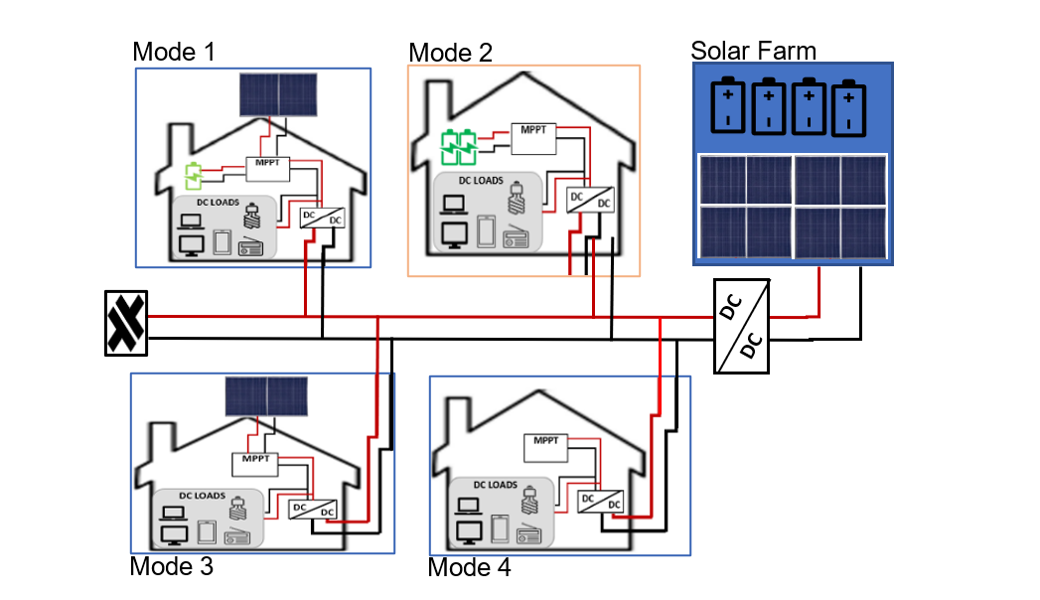

### Component technology.

DC microgrid systems utilize renewable energy technologies like Photovoltaic (PV) modules and wind turbines. Among these, PV modules are particularly common and readily available at affordable prices for consumers. In this research, PV modules will be exclusively employed as the energy source.

The primary objective of this study is to test the energy management system algorithm under various scenarios. This will be achieved by adjusting the system's resources in a manner that triggers all possible operating states. Specifically, energy storage capacity and loads will vary for each unit tested.

### Simulation and optimisation

The performance of the designed DC microgrid is modeled and simulated using Matlab/Simulink software. The simulation results are utilized to optimize system configurations, control strategies, and component sizing. This process aids in identifying potential improvements, evaluating system resilience, and validating the design.

**Software parameters required for load shedding regulation include:**

* + - * Defining Load Sizes: Since each household may have different loads connected to the system, and considering the limited grid energy, an algorithm will be developed to determine the allowable power consumption for each household based on their contribution.
      * State-of-Charge: SoC is a crucial parameter describing the remaining capacity of a battery. It is essential to monitor SoC during battery discharge to ensure efficient energy management.
      * PV Irradiance Input: Irradiance levels vary with weather and day/night conditions. This parameter provides information about the available solar energy that can be used to charge the batteries.
      * Connecting and Disconnecting of Loads: The system must be able to detect and react to changes, recalculating load shedding when significant loads are connected or disconnected.

### Implementation

A DC MG test bed will be constructed as described, incorporating key components such as DERs, energy storage systems, power converters, and control.

## Layout of dissertation

The final dissertation outline will consist of various chapters that form an integral part of the research project.

* **Chapter 1** provides an overview of the research. It outlines the primary research objectives and identifies the key questions this study seeks to answer. This chapter also includes a brief introduction to the significance of renewable energy in modern residential systems.
* **Chapter 2** presents a literature review that assesses and discusses the theoretical background on renewable energy sources, energy storage, energy management systems, and control methods. It critically examines previous studies and compares the best methods for optimizing energy management in residential systems. This chapter establishes the foundation upon which the subsequent research is built..
* **Chapter 3** discusses the methodologies employed in the development of a Residential Energy Management and Control System (REMCS), including its operating conditions, layout, and MATLAB simulations. The system's architecture and design considerations are explored in detail. Additionally, the chapter addresses the specific challenges and constraints encountered during the system's development.
* **Chapter 4** covers laboratory findings and simulation results, providing an analytical comparison of different units in the DC microgrid (MG). The chapter interprets data obtained from experiments and simulations, discussing their implications for energy management. It also explores the performance of various control strategies under different operating conditions.
* **Chapter 5** concludes the research project by summarizing key findings and proposing future work and recommendations. This chapter evaluates the overall success of the REMCS and its potential for future implementation. Furthermore, it suggests areas for improvement and future research directions in energy management systems.

Chapter 2

# LITERATURE REVIEW

## Introduction

In the landscape of modern energy systems, generation technologies play a crucial role in shaping the way we harness and utilize power. From traditional fossil fuel-based methods to cutting-edge renewable sources, Generation technologies encompass a wide spectrum of solutions that drive the transition toward sustainable and efficient energy production. This section delves into the diverse range of generation and storage technologies, exploring their mechanisms, advantages, and challenges, while highlighting the pivotal role they play in shaping our energy future. Microgrids integrate these diverse renewable energy sources and storage into a functional system. Furthermore, Strategies for efficiently integrating RES and ES are also discussed and finally the proposed study on the energy management system is presented.

## The Shift from AC to Decentralised DC Microgrids.

The first DC Microgrid was commissioned in 1882 [5], DC Microgrids. Over the years, alternating current (AC) became preferred over direct current (DC) due to its superior ability to transmit electricity over long distances. This shift was largely driven by advancements in AC technology and the ability to efficiently step up and down voltage levels using transformers, making AC the dominant standard for electrical transmission worldwide.

Advancements in renewable energy sources have sparked renewed interest in DC distribution, as these sources inherently produce direct current. Unlike AC generation technologies, Renewable energy source are distributed. Their decentralised nature allows renewable systems, such as solar panels and wind turbines, to be installed closer to the point of use.

There are three types of microgrids: AC, DC, and hybrid. Each topology comes with its own advantages and disadvantages. One major challenge in DC microgrid systems is the lack of standardization, particularly concerning voltage levels for residential, commercial, and industrial loads [6]. On the other hand, synchronisation poses a significant challenge in AC microgrids, especially within decentralized systems [7]. Hybrid microgrids capitalise on the distributed energy resource (DER) compatibility of DC microgrids while benefiting from the long-distance transmission capabilities of AC microgrids

## DC Generation Technologies

Direct current is produced by generators with commutators, fuel cells, rectifiers and photovoltaic cells. DC generators are rarely used in power plants due to extensive use of AC over DC in transmission lines. [8]. Photo voltaic arrays generate DC electricity in the presence of adequate sun radiation, in case where the sun radiation is inadequate, wind generation is utilized by using rectifiers. M.S. Keerthana et al. [9] demonstrated a dual source DC Microgrid by using wind and solar.



### Photovoltaic Panel

When sunlight (photons) strikes the photovoltaic cells, it releases energy that frees electrons from the semiconductor material, generating an electric current. The flow of electrons creates a direct current electricity within each photovoltaic cell. Multiple cells are connected in series or parallel to achieve the desired voltage and current levels. The generated DC electricity from the individual cells is combined within the panel using wiring and junction boxes. These components connect the cells and allow the collected electricity to be routed to the panel's output terminals.

A Matlab/Simulink model of a PV cell equivalent is shown in Figure 2.1.

The model shows a current source (IL), diode, series resistance (Rs), and shunt resistance (Rsh) to represent the irradiance- and temperature-dependent I-V characteristics of the modules.

Figure . A Matlab/Simulink model of a PV cell

The voltage-current characteristic equations for the model above are defined as:

|  |  |
| --- | --- |
| $I_{d}=I_{o}[\exp\left(\frac{V_{d}}{V_{T}}\right)-1]$ | (1) |
| $V_{T}=\frac{kT}{q}×nl×Ncell$ | (2) |

Where:

$$I_{d}= Diode current(A)$$

$$V_{d}= Diode voltage(V)$$

$$I_{o}= Diode saturation current(A)$$

$$nl= Diode ideality factor$$

$$k= Boltzman constant: {1.3806e}^{-32} J.K^{-1}$$

$$q= Electron charge: {1.6022e}^{-19}C$$

$$T= Cell temperature (K)$$

$$Ncell= Number of cells connected in series in a module$$

The PV cells capture the energy of the sun and convert it into electricity. There are three main categories of PV panel options: Monocrystalline solar panels, Polycrystalline solar panels and thin-film solar panel.

Polycrystalline panels, made from multiple silicon crystals, are characterized by a light blue color and distinctive crystal edges. While they are less efficient and more sensitive to high temperatures, they are widely used due to their lower cost compared to monocrystalline panels.

Monocrystalline panels, known for their high efficiency, use single-crystal silicon cells. They outperform other photovoltaic technologies in configuration [10], although thin-film panels, which consist of various semiconductor materials in thin layers, can sometimes yield slightly better performance due to a low temperature coefficient. Thin-film panels are flexible and versatile, but generally have lower efficiency than crystalline panels.

### Thermoelectric generators (TEGs)

Thermoelectric generators (TEGs) convert heat into electricity using the Seebeck effect, where a temperature difference across a thermoelectric material generates an electric current. Despite their potential, TEGs have low efficiency and high costs [11], restricting their use to specialized applications [12], [13]. Research continues to improve TEG efficiency for broader use, although increasing Thermal Energy Modules (TEMs) does not linearly boost power generation [14].

### Wind Turbine

A wind turbine is a device that converts the kinetic energy from the wind into mechanical energy and then transforms it to electricity. Wind turbines harness the power of the wind, and it is considered clean energy because no greenhouse gases are emitted during its operation.

A typical wind turbine consists of rotor blades, a tower, and a nacelle. The wind makes the blades spin and rotate a shaft connected to a generator [15]. Wind turbines are inherently alternating current by nature. For use with other renewable energy sources such as PV, wind turbines must be converted to DC.

## DC Distribution

The DC distribution is the preferred topology for microgrid distribution systems. Nandini K.K. [16] listed the following advantages of DC distribution system over AC:

* The power factor is not necessary for calculating distribution loss in a DC system.
* The power losses associated with capacitance charging and discharging are eliminated.
* There is no requirement to consider utility grid synchronization or reactive power in the DC system.
* The battery converter primarily regulates the DC bus voltage using linear feedback.

DC has its own disadvantages which include the lack of standardisations for LVDC distribution networks which were noted by, Katar et al [17]. DC transmission lines has two basic distribution structures, the unipolar and bipolar system.

In a unipolar system in Figure 2.2, electric energy is carried over two voltage lines, the VDC and 0Vdc for reference.

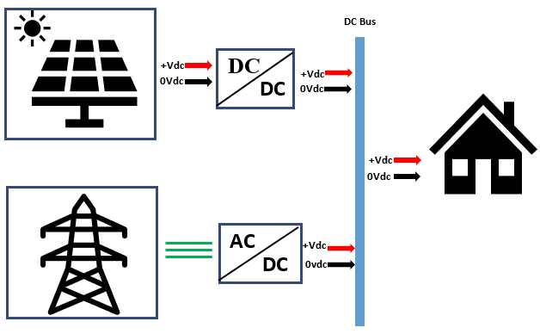

Figure .: Uni polar grid

The bipolar distribution system Figure 2.3 carries three voltage lines, the +Vdc, the reference and the -Vdc.

Figure . Bi-polar grid

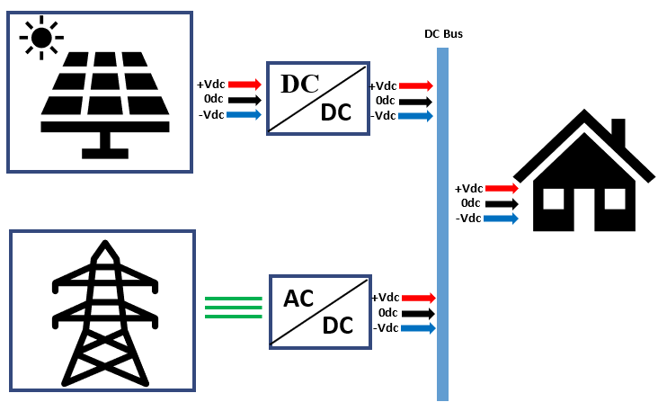

## Energy Storage Technologies.

Due to the intermittent nature of RES, which off-grid MG heavily relies upon, energy storage systems are used to power the grid when there is not enough sunlight for PV or wind speed to output the required energy to meet demand.

There a many energy storage types, and each type can be further sub divided into categories. Table 2.1 shows different types of energy storage systems:

Table 2.1 Types of energy storage

|  |  |
| --- | --- |
| **Type of Energy Storage** | **Description and Applications** |
| Batteries | - Lithium-ion: Portable electronics, EVs  - Lead-Acid: Automotive, backup power, renewables  - Nickel-Metal Hydride: Hybrids, stationary  - Flow Batteries: Grid-scale, scalability  - Sodium-Ion: Grid-scale, emerging alternative |
| Pumped Hydroelectric Storage | - Water pumped to higher reservoir during low demand, released for peak |
| Compressed Air Energy Storage | - Compressed air stored, released through turbines |
| Flywheel Energy Storage | - Energy stored in rotational motion of flywheel |
| Thermal Energy Storage | - Heat or cold stored in materials for space heating, cooling |
| Hydrogen Energy Storage | - Electrolysis of water to produce hydrogen for power, transportation |
| Superconducting Magnetic | - Energy stored in superconducting coils, rapid discharge |
| Thermochemical Energy Storage | - Energy stored in chemical reactions, releases energy on demand |
| Electrochemical Capacitors | - High-power, quick charge and discharge |
| Gravitational Energy Storage | - Lifting weights for potential energy storage, releases for electricity |



### Electromechanical Storage

Batteries represent the most prevalent form of energy storage and belong to the category of electromechanical storage solutions [18]. Electromechanical storage involves conversion of chemical energy into electrical or vice versa through reduction-oxidation(redox) reactions. Batteries are electromechanical devices that store and release electrical energy through redox reaction.

A range of battery varieties are employed for energy storage purposes, encompassing lead acid batteries, lithium ion, sodium nickel chloride, nickel cadmium battery, etc. These batteries vary in their respective characteristics and application.

Renewable energy storage relies on various battery types to store excess energy generated from renewable sources like solar and wind. Lead acid battery are the oldest rechargeable batteries [19]. They are well suited for application where reliability and cost are primary considerations. On the other spectrum Lithium ion is very costly however the make up in cost by their high energy density, efficiency, and life cycle.

### Hydrogen Energy Storage (HES)

Hydrogen energy storage uses hydrogen gas as a means to store and release energy. A fuel cell is used to store hydrogen energy. In a fuel cell hydrogen and oxygen react to form water to produce electricity. This method has gained attention as a versatile and potentially sustainable solution for addressing energy storage and distribution challenges.

### Mechanical Storage

Mechanical storage is the process of storing energy in mechanical systems and converting it back to usable energy when needed. The types of mechanical storage include pumped hydroelectric storage (PHD), Compressed Air Energy Storage (CAES), Flywheel Energy Storage, Gravitational Energy Storage. These types of energy storage have geographical and environmental constraints.

### Super Capacitor Energy Storage (SES)

Supercapacitors use polarized liquid layers between conducting ionic electrolyte and conducting electrode to increase the capacitance. They have a very high energy density and power. Supercapacitors have a very low stage of charge compared to other electromechanical storage systems [20]. They can be used to suppress power fluctuations in Wind and PV systems, they are generally combined with a battery system in a hybrid storage system.

### Thermal Energy Storage (TES)

Thermal energy storage is a method of storing thermal energy by heating or cooling and releasing it when needed. TES systems can also be used to mitigate the intermittent of renewable energy sources, by storing heat in water tanks, molten salts, or another material.

## Microgrid types

A typical Microgrid system consist of Converters, Energy storage, Energy sources, communication infrastructure and control system. Microgrids vary in scale, voltage level, mode of operation and control system.

There are three types of microgrids: AC, DC, and hybrid. Each topology comes with its own advantages and disadvantages. One major challenge in DC microgrid systems is the lack of standardization, particularly concerning voltage levels for residential, commercial, and industrial loads [6]. On the other hand, synchronization poses a significant challenge in AC microgrids, especially within decentralized systems [7]. Hybrid microgrids capitalise on the distributed energy resource compatibility of DC microgrids while benefiting from the long-distance transmission capabilities of AC microgrids. The use of inverters is a limiting factor in hybrid systems [21]

## Operational Strategies for DC Microgrids

There are two basic modes in which DC MGs are operated: Grid-connected and Off grid. Grid-connected in this instance means that the DC MG is connected to the utility, converters are used to convert from AC from the utility to DC used in DCMG transmission lines. EMS are integrated into MGs to improve efficiency and to maintain grid stability. In the absence of EMS control strategies for converters are used to improve grid performance.

Unlike the AC’s bus control systems which controls the AC bus voltage and frequency, the converters in DC microgrid have just one parameter to control, which is the DC bus voltage. [22] discussed three control schemes used in DC microgrids: Constant-current control, constant voltage control, and droop control.



### Constant-current control

The constant-current control aims to keep the bus current at constant level and change in demand may greatly affect DC bus voltage. Energy storage systems can utilize the constant-current control strategy to help recover bus voltage in a short time.

### Constant-voltage control

This strategy aims to keep the voltage stable. Ultra-capacitors are used to reduce the fluctuations caused by changes in load demand.

### Droop control

The Droop control strategy is used to stabilize the voltage and solve the load sharing problem. [22]. [23] explained droop voltage using DC system voltage-current characteristic line (V-I characteristic line). The load demand will cause a change in the output current of converters, which will lead to the drop of bus voltage. The droop control scheme is the same as that of voltage-control, with the difference being reference voltage is replaced by droop voltage.

Figure . DC voltage-current characteristic line

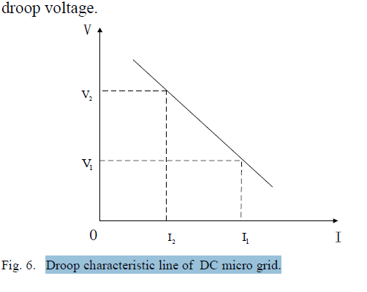

Mohammed A.A et al [24], describes hierarchical control in their DCMG systems as consisting of three level; primary, secondary, and tertiary control.

* + - Primary control deals with voltage/current regulation, and control of local power-sharing.
    - Secondary control works on the top of primary control dealing with voltage compensation, power quality regulation, microgrid synchronization with any external grid, etc.
    - Tertiary control is the highest level and is responsible for optimization, power management, economic dispatch, and overall system regulation.

A communication less decentralised power-sharing method for composite storage devices developed by [25], their strategy allows plug and play of multiple batteries and ultracapacitors by implementing a master-slave control on additional batteries. This paper does not guarantee full equalisation of SoCs. Equalisation is highly dependent on load and power generation.

### DC Voltage standards

Standardization is a major challenge in DC microgrid systems, as there are currently no established standards for voltage levels in residential, commercial, and industrial loads [7].

. [26] highlighted that the voltage level of a DC distribution system should be selected to maximize efficiency and reliability while minimizing costs and enhancing system flexibility. However, achieving this often requires a high-voltage DC bus, which introduces challenges related to system safety and protection, potentially leading to fire hazards.

## EMS-integrated DC MG

Energy Management Systems are used in MG to improve grid performance, reduce operational costs, and increase efficiency [27]. Different algorithms for EMS have been proposed for different MG topologies such as [28], [29] and [30]. [31] proposed a 4-level DC-based home management system to meet voltage levels of home appliances and devices. The EMS proposed in [32] improves efficiency and power management by introducing three modes of operation: power mode, deficit, and power balance mode.



### Multi-level approach

Multi agent systems in microgrids are made up of units called agents. From the MG perspective, agents are HEMS connected to it. The agent on the MG can be configured in two ways, centralised multi-agent coordination and de-centralised agent coordination. Figure 2.5 illustrates the centralised multi-agent coordination described by [30], the coordinator is the central agent, it is responsible for commination between the agents.

Figure . Centralised multi-agent coordination

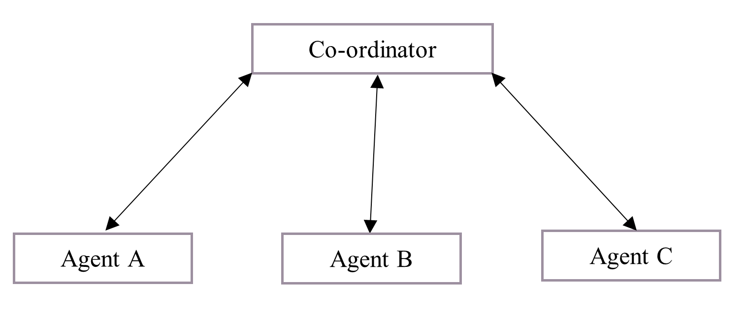

A de-centralized multi-agent co-ordination is shown below. In this architecture, the agents work independently, they communicate to each other to determine the status of other agents so they can perform the same task by associated motives.

Figure .: De-centralized multi-agent co-ordination

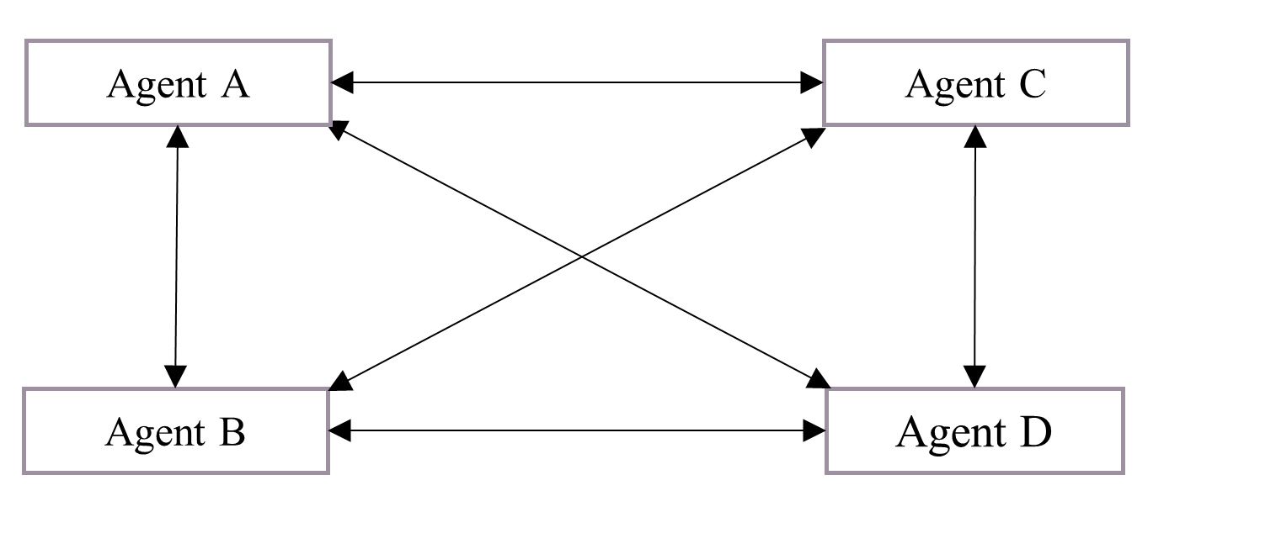

## Proposed study

A microgrid can be defined as power cluster of distributed generation, load, and energy storage device accumulated together in the vicinity to each other [33]. The most used distributed generation in residential areas are PV [29]. The flexibility of the proposed EMS allows for residential units to be configured as DG, ESS, load, or any combination, depending on the resources available in the unit [34].



### Systems of Systems (SoSs)

Ahmad Alzahrani et al. [35] described as a Systems of Systems (SoSs). SoSs are integrated systems that are diverse and autonomous but work together to achieve common goals. The systems can work together or independently. Table 2.2 below shows some characteristics of SoSs.

Table 2.2: Systems of Systems characteristics

|  |  |
| --- | --- |
| Characteristic | Definition |
| Operational Independence | All subsystems work independent and have no interference with other subsystems |
| Evolutionary development | Flexible to adding new subsystems |
| Emergent behaviour | The overall system works as collective unit to accomplish a big task |
| Geographic distribution | The subsystems are sequentially distributed to facilitate the flow of information |
| Managerial independence | The subsystems are in control of their own operation. |

From a microgrid layout, REMCS (Residential Energy Monitoring and Control systems) are systems that connect to another system such as CGMS (Central Grid Management system). REMCS subsystems capable of operating independently without any input or interference from CGMS.

### Modelling the microgrid for the EMS using SoSs

The SoSs have characteristics that allow easy integration of the EMS into the microgrid, with each system working independently, failure of one system will have little impact on the overall operation of the grid. Figure 2.7 below shows the DC microgrid connected to RES, loads and storage systems.

Figure .: DC MG Systems of Systems

## Proposed study

In this section, energy generation, storage and distribution methodologies were reviewed to determine the best solution for DC MG application. From the studies above and taking account of all the cited references, energy management systems differ greatly due to grid attributes, such as centralised and decentralized, voltage regulation, frequency control, etc.

The current study proposes the adoption of a decentralized energy management system for the DC MG, characterized by a non-communicative framework. This approach capitalizes on the power sharing concept elucidated in reference [25] ,while additionally introducing a System of Systems framework to enhance control mechanisms and operational efficiency.

.

Chapter 3

# THEORETICAL CONSIDERATIONS

## Introduction

This chapter presents feasibility study and planning, power balancing and control mechanisms, and battery energy storage systems. Additionally, model development of the DC microgrid and a discussion on the state chart model for the Energy Management System (EMS) are provided. By systematically examining these aspects, the objective is to establish the grid structure to be utilized in the simulation.

## Feasibility study and planning

The objective of this study is to implement an energy management system in a DC microgrid with the aim of enhancing overall system performance. The feasibility studies for the EMS are closely reliant on the feasibility study of the DC microgrid, given that they constitute an addition to the DC microgrid. The feasibility of DC MG is studied in this chapter.

The viability of DC MG in residential areas is evaluated in comparison to the ac grid in terms of conversion efficiencies in [36] and [37]. The author concluded that DC systems with local generation and storage encounter less conversion losses, this was supported by [38], they developed AC and DC models for comparison and concluded that when AC power system is supplied by a DC source, further losses can be expected resulting in further benefits of a DC distribution system. The highest efficiency is attained when DC sources supply DC loads, and AC sources supply AC loads. The positive outcome demonstrated in [39] has established the feasibility of directly supplying appliances with DC voltage.

## Resource Assessment and Design



### Battery Energy Storage System

The battery SOC level determines the duration of use of electrical energy after sunset [40] and if the battery capacity is too low the grid is likely to shut down. For the EMS to effectively keep the grid stable the SoC of the battery must always be known. The charging/discharging effect on SoC can be represented by the following equation [41];

|  |  |
| --- | --- |
| $${SoC}_{bat,t}= {SoC}_{bat,t-1}+(η_{c}P_{bat,t-1}^{c}-\frac{η_{c}P_{bat,t-1}^{dc}}{η_{d}})$$ | (3) |
| $${SoC}_{bat,min} ≤ {SoC}_{bat,t} ≤ {SoC}_{bat,max}$$ | (4) |

where ${SoC}_{bat,t}$ is the battery SoC at time 𝑡; $η_{c}$ is the charging efficiency; $η_{d}$ is the discharging efficiency; $P_{bat,t-1}^{c}$ is the charged power at time 𝑡−1; $P_{bat,t-1}^{dc}$ is the discharged power at time 𝑡−1; and 𝛥t is the time step. The BESS minimum and maximum charging and discharging power constraints at time 𝑡 can be written as:

|  |  |
| --- | --- |
| $P_{bat,min}^{c}≤ P_{bat,t}^{c} ≤ P_{bat,max}^{c}$ | (5) |
| $P_{bat,min}^{dc}≤ P_{bat,t}^{dc} ≤ P_{bat,max}^{dc}$ | (6) |

The scalability and quietness of solar panels allow for easy integration into residential areas. Battery storage systems ensure energy independence for residential units and grid stability. compared to the other energy storage systems studied in this paper, battery storage systems can be modular, allowing for incremental capacity additions.

### Power Balancing and Control

The power balancing strategies are classified as: centralized, decentralized and distributed. In centralized control, the central controller acquires system information for control, decisions, and schedules tasks. The decentralized control operates on local quantity measurement. A distributed control uses DC bus signaling in which bus voltage is the communication carrier to decide operation modes [42].

A modified distributed control is used in this paper. A web-based communication protocol is used to communicate bus voltage and other parameters to the main control, nodes can still operate individually.

The type of control used by the nodes operates the same across all nodes. The equation below measures the power available to the load on a specific node.

|  |  |
| --- | --- |
| $P_{LOAD}=P_{GRID }+P_{PV}+P_{BAT}$ | (7) |

Where PPV, PBAT, and PGRID function as input power to local load. PLOAD is power drawn by the load.

DC bus voltage shifting from charging mode to discharging mode.

|  |  |
| --- | --- |
| $P_{BAT}=P_{LOAD }-P_{PV}-P_{GRID}$ | (8) |

When there is less solar radiation, the battery gets discharged the power available to the load and grid, would be the battery. If the load gets priority, power sharing is disabled.

In the case of more radiation, the battery gets charged, however, overcharging the battery is avoided. Excess power is shared with the grid. The central control ensures grid stability by making decisions for the nodes connected to the grid. In this control, there are N number of nodes. $P_{GRID }$ is obtained from equation 9.

|  |  |
| --- | --- |
| $P_{GRID }=P_{PV }+P_{BAT }+\sum_{i=1}^{N}{P}\left(i\right)$    | (9) |

where:

$$P_{PV} is the solar farm PV$$

$$P_{BAT} solar farm battery storage$$

$P\left(i\right) is the to total power shared by the nodes$.

### Energy Management System

Figure 2 below shows the proposed state machine control strategy for residential unit 1. Load demand is determined using probabilistic load demand for the renewable energies proposed in [43] . This control strategy prioritises battery charging while there is still power being generated from RES. The unit enters a power sharing state when there is surplus energy from the PV panels.

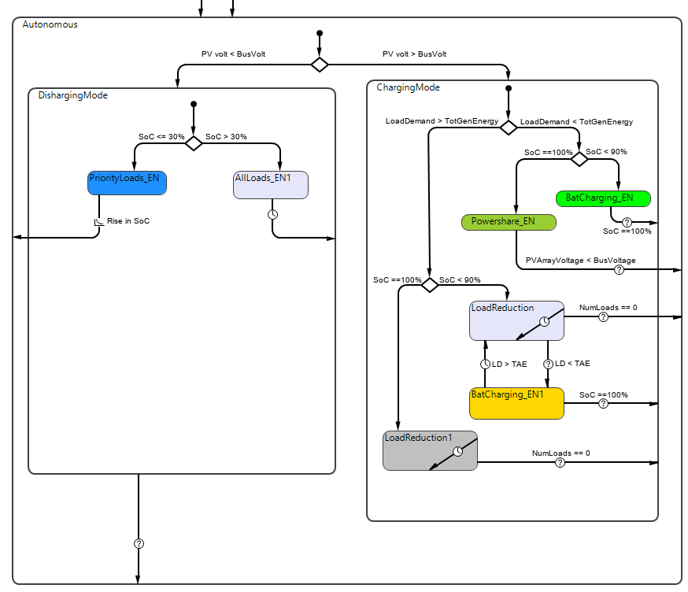

Figure .: Operating mode 1 strategy

Figure 3.1 illustrates the control strategy for mode 2 operation, where the unit functions as a battery storage due to the availability of battery capacity. In this mode, priority is given to battery charging, ensuring that the load can continue to operate long after sunset. When there is insufficient energy from the grid to charge the battery and meet the load demand, the system activates the load reduction state.

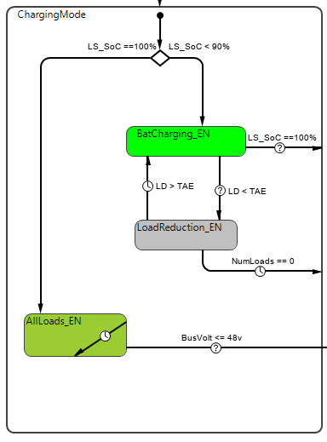

Figure .: Operating mode 2 strategy

Mode 3 characterizes a residential unit that generates power but lacks a storage system. Figure 3.2 illustrates the state machine for this unit. The system enters a power-sharing state when the PV array generates sufficient power to meet the local demand. The State of Charge (SoC) of distributed energy sources can be estimated with reasonable accuracy using the filtered terminal voltage method proposed in in [44]. This estimation allows the residential unit to contribute energy to charge the Energy Storage System (ESS) on the grid.

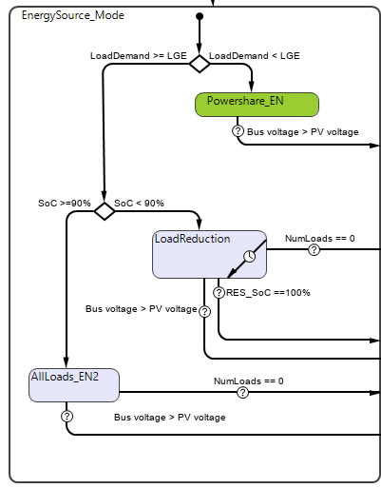

Figure .: Operating mode 3 strategy

The control strategy for modes without any energy source or battery storage is simple: load reduction is triggered when the solar farm State of Charge falls below 10%. This system solely relies on external power sources.

Figure 3.4: Operating mode 4 strategy.

## Conclusion

In this chapter, we conducted a feasibility study of the Energy Management System and the DC Microgrid as a whole. Several authors have demonstrated the feasibility of DC MGs for residential use, with the EMS serving as an enhancement to the DC MG. We also explored power balancing and control strategies for managing units connected to the MG. The MG can be configured to operate in both centralized and decentralized (autonomous) modes. Additionally, state charts for the units were developed.

Chapter 4

# METHODS AND MATERIALS

## Introduction

System Overview The aim of this paper is to introduce a Direct Current microgrid Energy Management System utilizing system of systems. The proposed system involves the integration of renewable energy sources, energy storage, and demand management within a microgrid framework. The MATLAB Simulink environment is employed to model and simulate the system.

## Microgrid configuration

The microgrid comprises four houses, each symbolizing a unique scenario. As depicted in Figure 4.1, these houses are interconnected with the Central Grid Management System (CGMS) via a microgrid. In the MATLAB Simulink model, each house is represented as a distinct block

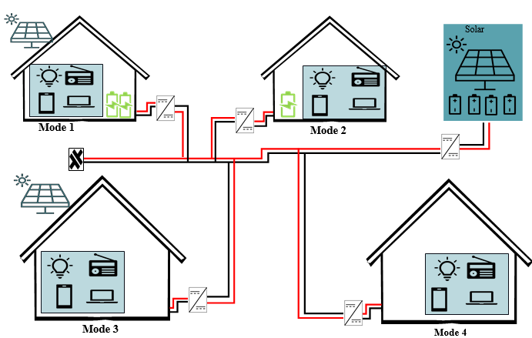

Figure . Residential unit operation modes with solar farm

## Scenarios for diverse inputs

The four houses in the microgrid allow for the simulation of various scenarios that serve as input parameters for the CGMS:

Scenario 1: Node with Storage System In this scenario, a node within the microgrid is equipped with an energy storage system. This system can both store and source energy, providing flexibility in managing energy demand and supply.

Scenario 2: Node without Storage System This scenario involves a node that lacks an energy storage system. Energy can only be sourced from renewable sources (e.g., solar panels) during periods of sunlight.

Scenario 3: Node with Only Storage System Here, a node in the microgrid is equipped with an energy storage system but does not possess the capability to generate energy. It can only manage energy based on stored reserves.

Scenario 4: System Node with No Energy Interaction This scenario represents a node in the microgrid that neither stores nor sources energy. It serves to demonstrate the impact of non-participating nodes on the overall energy management system.

## Matlab Simulink Model

The proposed microgrid EMS and scenarios are implemented using the Matlab Simulink platform. Each scenario is modeled as a separate block, with appropriate connections to represent energy flow, storage, and interaction with the microgrid.

## Validation and Verification

The proposed microgrid EMS's validity is confirmed by conducting comparisons with a laboratory model and benchmark scenarios. Sensitivity analysis is conducted to assess the system's robustness to varying parameters.

## Microgrid Formation

By combining these individual house blocks, a comprehensive microgrid is formed. This microgrid is integrated with the CGMS, allowing for centralized energy management and coordination across the various scenarios. In the absence of CGMS, the microgrid can still operate under systems of systems rule.

The formation of a microgrid involves the integration of four distinct units, each of which presents a unique scenario for analysing the response of the energy management system.



### Photo Voltaic Solar Panels

In the evaluation of the system, two series of interconnected PV modules with parameters as specified in Table 1 are employed. The output voltage and current of these PV modules are calculated by applying irradiance and temperature data sourced from [45], utilizing the following equation:

|  |  |
| --- | --- |
| $I_{d}= I_{0}[e^{\frac{V_{d}}{V_{T}}}-1]$ | (10) |
| $$V_{T}= \frac{kT}{q}×nI ×Ncell$$ | (11) |

Table 4.1: PV array parameters

|  |  |  |  |
| --- | --- | --- | --- |
| **Parameter (Unit)** |  | **Solar Farm PV** | **Residential PV Panel** |
| Maximum Power (W) |  | 330 | 330 |
| Open circuit voltage(V) |  | 36.84 | 48 |
| Short-circuit current Isc (A) |  | 100 | 19.896 |
| Voltage at maximum power point Imp (V) |  | 100 | 22 |
| Current at maximum power point Imp (A) |  | 55.87 | 55.87 |

Table 4.2 displays the irradiance and temperature data intended for use as input parameters in the PV simulation block. Given their close proximity, it can be inferred that the irradiance will be consistent across all units

Figure .: Photo Voltaic Generation Irradiance and Temperature 8/16/2020 [42]

### Battery Storage Capacity

The battery's capacity rating, as illustrated in Table 4.2 Shows two battery capacities used in this paper, The solar farm energy storage system (SF ESS) and Residential energy storage system (RE BSS). The Solar farm battery storage boasts a substantial maximum capacity of 100 ampere-hours (Ah), enabling it to store a significant amount of electric charge. With a nominal voltage of 48 volts (V), SF ESS maintains a consistent grid operating voltage while it is charged. RE BSS is a specialized energy storage solution operated by a REMCS in a MG, it is designed to complement SF ESS.

|  |  |  |
| --- | --- | --- |
| **Parameter (Unit)** | **SF ESS** | **RE BSS** |
| Maximum capacity (Ah) | 100 | 22 |
| Nominal voltage(V) | 48 | 48 |
| Nominal capacity (Ah) | 100 | 19.896 |
| Rated capacity (Ah) | 100 | 22 |
| Fully Charged Voltage (V) | 55.87 | 55.87 |
| Cut-off voltage (V) | 36 | 36 |

Table 4.2: Energy storage parameters

The energy storage block in Simulink offers a versatile configuration that can accommodate a wide range of battery storage options. In the context of this research, the selected energy storage technology is lithium-ion batteries. Lithium-ion batteries are chosen for their well-established performance characteristics, high energy density, and suitability for various applications. Their adaptability within the Simulink framework ensures that they can be used effectively in the context of the research project.

Figure .: Battery Storage System

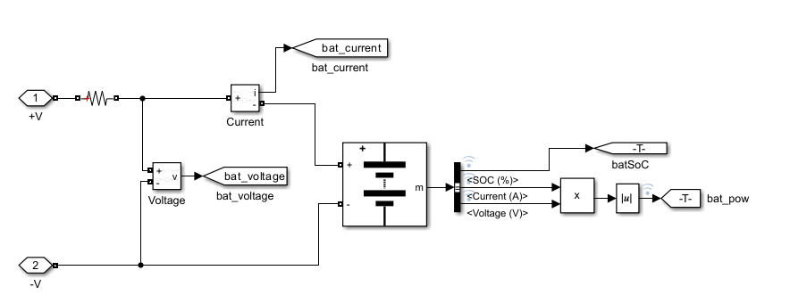

### Load Profile

Internally, most of the appliances operate on DC [46]. With the improvement in technology such as USB power delivery (USB-PD) standards, appliances such as LCD TV, laptops and monitors can be powered directly from USB connection. The load profile provided in figures 4.4 – 4.7 are utilised to model various load conditions experienced by the units over a 24-hour period.

Figure .: Load demand: Profile 1



Figure .: Load demand: Profile 2



Figure . Load demand: Profile 4

Figure .: Load demand: Profile 3





Matlab Signal editor block is used to produce load profiles during simulation time.

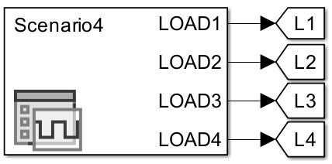

Figure . Load profile waveform selector

Figure . REMCS unit Matlab overview

Figure 4.9 displayed above illustrates a Matlab/Simulink representation of an REMCS unit connected to a solar farm through a DC MG. units’ configuration can be modified by addition and or removal of ESS and BSS. In the REMCS block, an MPPT system interfaces with the PV module, and a bidirectional DC-DC converter connects to the external Grid. Several switches are employed to control the grid.

The load block consists of four distinct resistive loads that are turned at different interval to produce the load profiles discussed.

.

Figure .: REMCS nano grid

The load block consists of four distinct resistive loads that are turned at different interval to produce the load profiles discussed

Figure .: Loads control circuit

The load demand for the load profiles is determined by adding up the total power consumption of all activated loads as depicted in the figure below.

Figure .: load demand block

## REMCS Design Logic



### State Observer

The Systems of Systems framework allows REMCS units operate fully independent without direct communication to other units in the grid. The state observer REMCS, using power flow and voltage measurements can determine the state of the grid and respond accordingly.

The Systems of Systems philosophy empowers REMCS units to operate as self-contained entities, operating independently without the necessity for direct communication with other units interconnected in the grid. Instead of relying on constant coordination or centralized control, these REMCS units are designed to function autonomously, ensuring flexibility and robustness in the overall system.

Within this framework, a state observer is integrated into the REMCS. This observer uses power flow and voltage measurements to assess and monitor the state of the grid. By continuously analysing these key parameters, the state observer can determine the health, performance, and stability of the grid at any given moment.

This capability provides several advantages. First, it enables each REMCS unit to make informed decisions in real-time, optimizing its own operations based on the grid's condition. Second, it enhances the grid's resilience since REMCS units can respond to changes or disturbances independently.

Figure .: State chart block

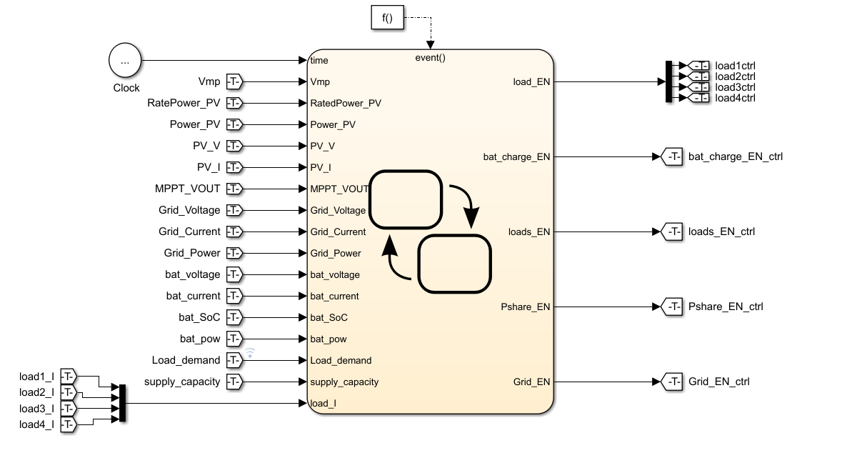

The state chart block transitions the REMCS unit to four distinct states whereby each resource configures the system resource for optimal performance. These states represent different operational modes that the REMCS unit can adapt to as it interacts with the grid. Each state is designed to align with specific objectives and requirements, optimising resource allocation and utilisation. Three states are connected to Start, Running on Battery, PowerShare and charging.

#### Running on Battery State

The criteria for transitioning into the *Running on Battery* state depend on two key factors: the availability of solar power and whether the PV modules have achieved their maximum power point voltage (Vmp). The sub states implement load shedding when the battery SoC goes below 30% by reducing supply capacity. The systems leave this state when bat_SoC goes above the last recorded SoC before going into Running on Battery mode.

Figure .: Running on battery.

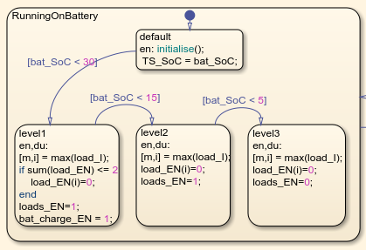

#### Charging State

The system transitions into a "Charging" state whenever the State of Charge drops below 100%. Upon entering this state, default configurations are applied. Within the Charging state, there are two priority charge substates, PR_CHRG_LVL2 and PR_CHRG_LVL3, designed to prioritise battery charging then load servicing.

During the PR_CHRG_LVL2 substate, load reduction measures are activated when the battery's SoC is below 50%. Charging continues until the SoC exceeds 75%, at which point load reduction is lifted.

Figure .: Battery Charging State

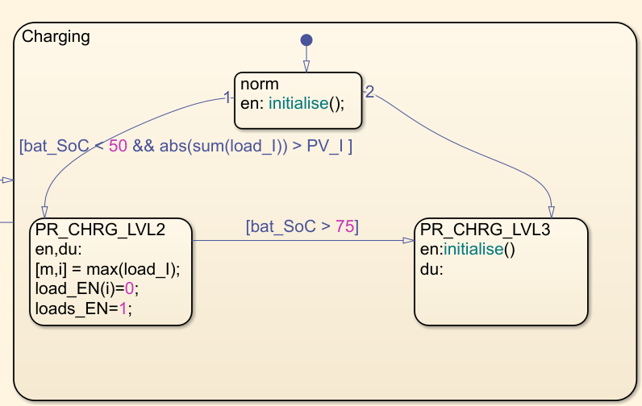

#### Power Share State

Upon reaching a battery State of Charge of 100%, and when the photovoltaic module generates an excess of energy beyond the local load requirements, the system enters a "Power-Share" state. In this state, the system is perceived as an energy source by both the central controller and any other units connected to this system.

Figure .: Power Sharing

## Model parameters

The performance of the EMS is determined by the following:

Bat_SoC – The energy storage system plays a crucial role in enhancing grid reliability by supplying power during periods when energy sources may not be dependable. It is imperative to prioritize battery charging whenever Renewable Energy Sources (RES) are actively generating power.

SF_SoC (Solar farm state of charge) The energy storage system within the solar farm provides power to all REMCS units and plays an important role in maintaining grid voltage stability. When systems operate autonomously, it is essential that they refrain from drawing power as the State of Charge of the solar farm's energy storage system approaches depletion.

Loads – Predicting and planning for load demand presents a challenge, primarily because consumers do not adhere to a rigid schedule for switching on their loads. In microgrid systems, demand-side management strategies, as discussed in [47], have been adopted to enhance efficiency, reduce utility bills, and serve various other objectives.

In summary, the integration of an EMS into the grid is anticipated to enhance the charging rate of local Battery Energy Storage Systems (BESS), particularly during daylight hours when PV modules generate power. This integration also plays a vital role in maintaining grid stability by reducing the discharge rate of BESS. Additionally, the Energy Management System (EMS) is responsible for effectively directing surplus power generated by PV modules back into the grid. To achieve these objectives, the EMS can implement strategies to reduce overall load demand.

The benchmarks mentioned above will undergo testing within all four scenarios, with each load profile depicted in figures 4.4 through 4.7 being applied. This testing procedure will serve as the means to assess the performance of the EMS.

Table 4.3:Scenario 1: Model setup parameters

|  |  |
| --- | --- |
| Irradiance profile | See Figure 4.2 |
| Battery size and capacity | Nominal voltage: 48 V DC  Capacity: 22Ah  Initial SOC: 50% |
| Load Size | Minimum: 60 (W)  Maximum: 570 (W) |
| PV module | Maximum power: 240.53(W).  Vmp: 30.72(V)  Imp: 7.83(A) |
| Load profiles used | Case study 1: Load profile 1(Figure 4.4)  Case study 4: Load profile 4(Figure 4.6) |



### Case study 1

Figure .: non-EMS Supply capacity with v load demand

Figure .: Supply capacity with EMS v load demand

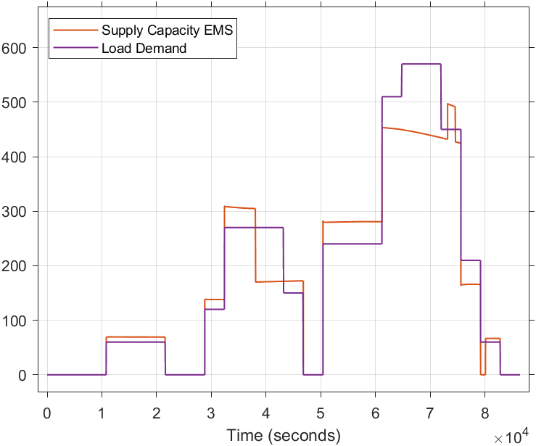

To satisfy the load demand, the supply capacity must consistently equal or exceed the load demand. The results obtained in Figure 4.18 demonstrate the capability of the energy source within the DC MG to fulfil the unit's energy load profile, particularly in the non-EMS integrated scenarios.

The inability of the EMS-Integrated DC MG to meet load demand can be traced to its energy prioritization feature, which allocates a portion of the available energy for battery charging.

Consequently, this feature results in a noticeable 10% improvement in the state of charge of local storage when compared to the non-EMS system, as illustrated in Figure 4.19 at time ${5×10}^{4}s$.

Figure .: Local Storage SoC EMS v non-EMS system

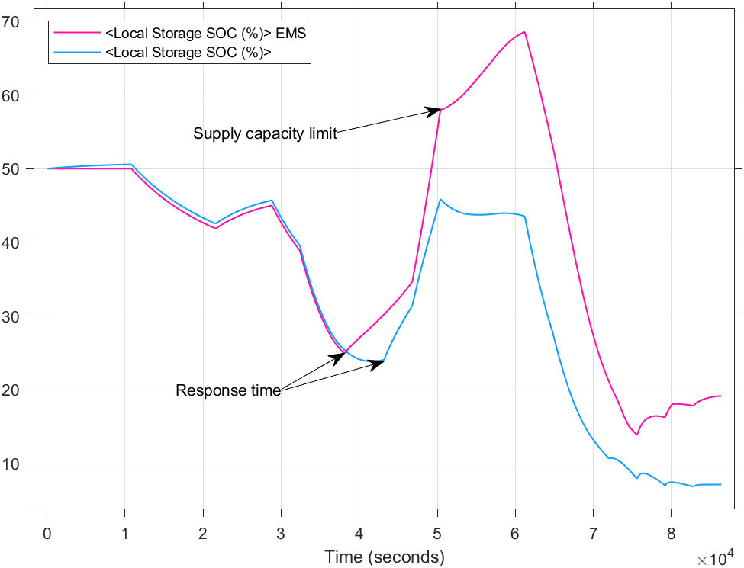

The initial differences in SoC observed after ${3.8×10}^{4 }$ seconds between the non-EMS DC MG and the EMS-integrated DC MG can be attributed to the EMS's response time when detecting sufficient power from RESs. Peak load demand commences around ${3.8×10}^{4 }$ seconds, which closely coincides with the moment when PV panels cease power production due to the sunset. During peak demand, the slope remains consistent for both systems, primarily because of the identical load profile and the fact that RES is not generating power. The load demand persists until approximately ${8.40×10}^{4 }$ seconds, causing a significant decline in the State of Charge (SoC) of both the solar farm and local energy storage. The Solar Farm SoC comparison is shown in Figure 4.19. To reduce dependence on external power sources, the EMS restricts the utilization of the solar farm's storage until the local storage drops below 15% or cannot meet the load demand. Solar farm SoC drops from 50% at time 0 seconds to 20% at time 86400. EMS-integrated systems have 16.5% more storage capacity than the non-EMS system as shown in Figure 4.20.

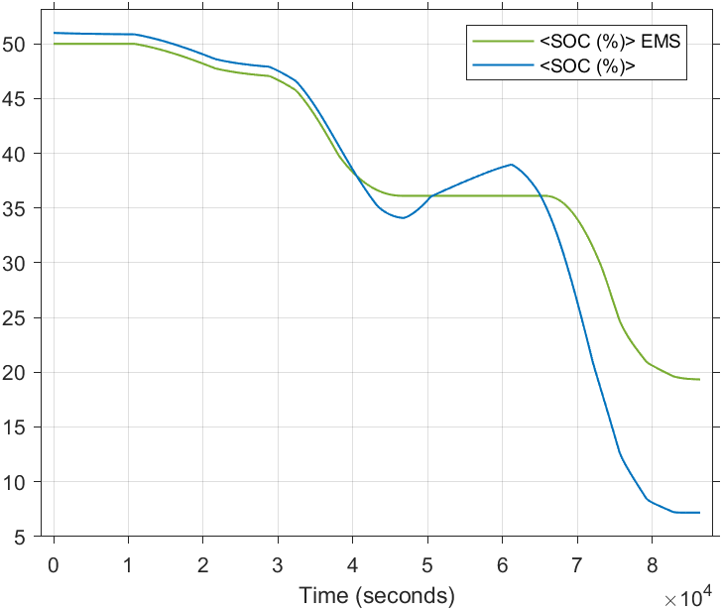

Figure .: Solar Farm Storage SoC EMS v non-EMS system

The load demand data for case study 4 is illustrated in Figure 4.22 and Figure 4.21, with a specific focus on highlighting the EMS local storage prioritization feature.

Figure .:Non-EMS Supply capacity v Load demand

Figure .: Supply capacity EMS v Load demand

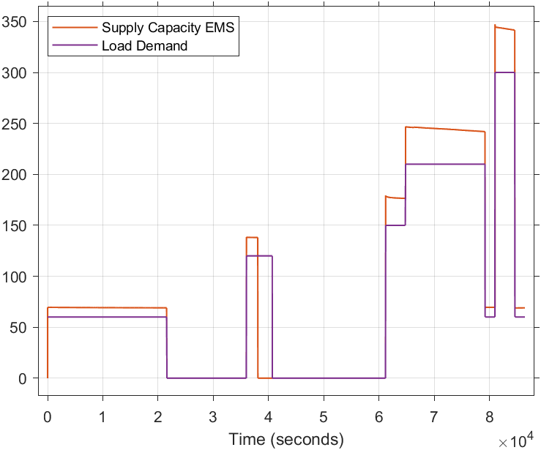

The comparison of local storage between the EMS and non-EMS systems in Figure 4.8.6 demonstrates the EMS's early response time and its charging rate. The higher charging rate of EMS systems results from using PV modules exclusively for local battery storage charging, as opposed to non-EMS systems which also have to charge solar farm SoC.

Figure 4.22 demonstrates the power sharing feature of the EMS. This feature activates when local storage is charged. Due to its higher charging rate, the EMS can bring the Solar farm SoC within 1% of the non-EMS system.

Figure .: Solar Farm Storage SoC EMS v non-EMS

Figure .: Local Storage SoC EMS v non-EMS

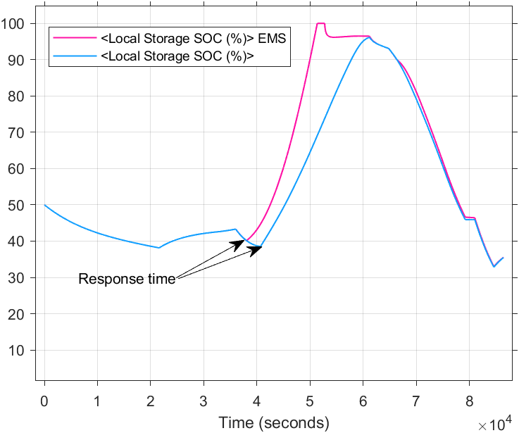

### Case Study 2

Table 4.4 Scenario 2: Model setup parameters

|  |  |
| --- | --- |
| Irradiance profile | See Figure 4.2 |
| Battery size and capacity | Nominal voltage: **0** V DC  Capacity: **0**Ah  Initial SOC: **0**% |
| Load Size | Minimum: 60 (W)  Maximum: 570 (W) |
| PV module | Maximum power: 240.53(W).  Vmp: 30.72(V)  Imp: 7.83(A) |
| Load profiles used | Case study 1: Load profile 1(Figure 4.4)  Case study 3: Load profile 3(Figure 4.7) |

Table 4.4 Scenario 2: Model setup parameters provides a profile for Unit 2 REMCS, which relies heavily on solar power. In the absence of local energy storage to store excess power generated from the PV modules, the EMS enables the power-sharing module when the load demand is reduced, allowing for efficient use of the surplus energy.

Figure .: Non-EMS Supply capacity v load demand

Figure .: EMS Supply capacity v load demand

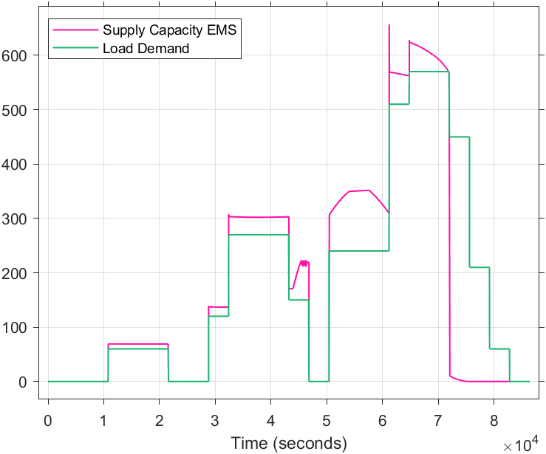

The load demands versus supply capacity for the two systems are depicted in Figure 4.25 and Figure 4.26. Both systems can meet load demand until ${7.20×10}^{4 }$ seconds for the EMS system and ${7.60×10}^{4 }$ seconds for the non-EMS system.

Figure .: Solar Farm SoC EMS v non-EMS

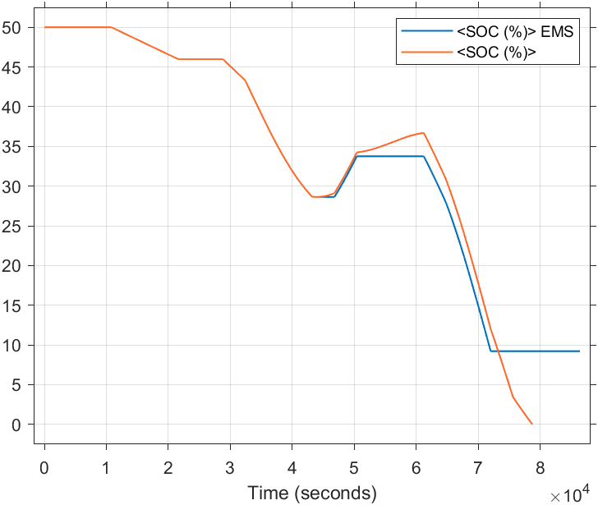

Referring to Figure 4.25, the Solar farm gradually decreases its state of charge (SoC) from time 0 seconds to approximately ${4.30×10}^{4 }$ seconds. Due to high load demand, the solar farm's SoC increases by 10% for the EMS system and 15% for the non-EMS system. The lower SoC in the EMS system compared to the non-EMS system can be attributed to the EMS's prioritisation of local energy storage, which attempts to charge local batteries that are non-existent for this particular unit, this defaults the EMS to Start. Start state is verified in Figure 4.28 from time ${5×10}^{4 }$ seconds to time ${6.02×10}^{4 }$ seconds.

Figure .: local SoC and state transition

Figure .: Non-EMS Supply capacity v load demand

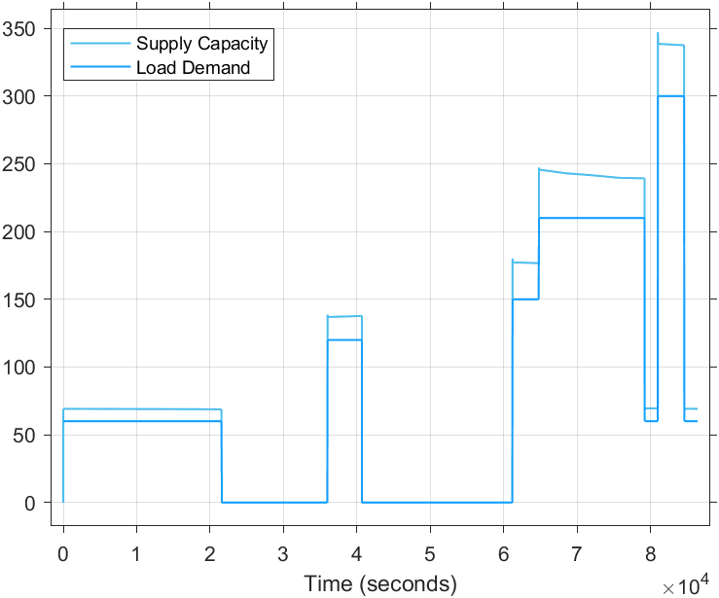

Figure .: EMS Supply capacity v load demand

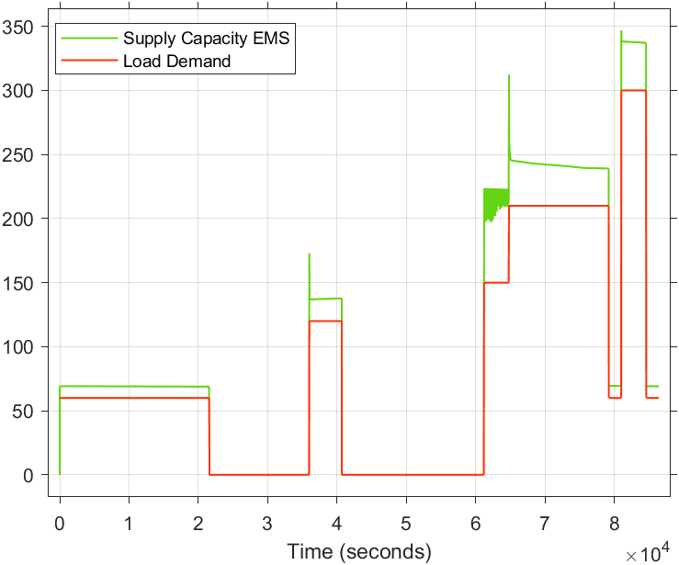

Supply capacity results for Load Profile 3 are displayed in Figure 4.29 and Figure 4.30. The demand for this profile peaks at 350W, which can be adequately powered by both PV modules and the solar farm source.

Figure .: Solar Farm SoC EMS v non-EMS

Due to this moderate demand, the EMS and non-EMS systems increase the solar farm SoC to 69% and 71%, respectively. In the absence of battery storage detection, the EMS switches to its default Start state, leading to a 2% lower SoC compared to the non-EMS system as shown in Figure 4.32.

Figure .:EMS supply capacity and state transition

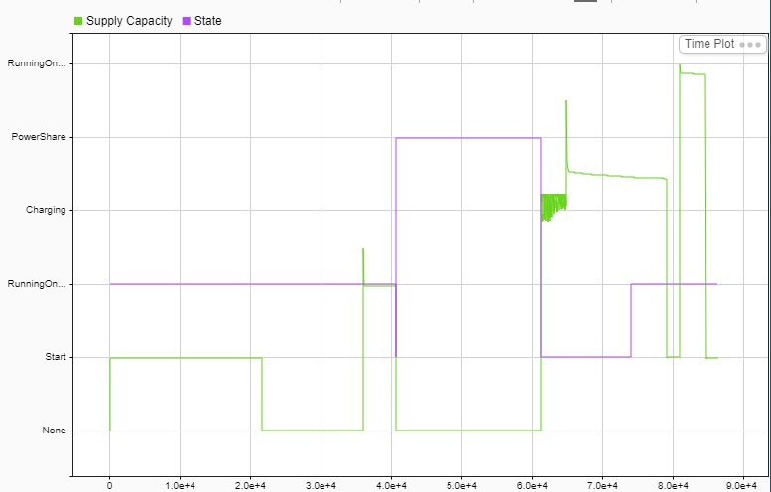

### Case Study 3

Table 4.5: Scenario 3: Model setup parameters

|  |  |
| --- | --- |
| Irradiance profile | See Figure 4.2 |
| Battery size and capacity | Nominal voltage: 48 V DC  Capacity: 22Ah  Initial SOC: 100% |
| Load Size | Minimum: 60 (W)  Maximum: 570 (W) |
| PV module | Maximum power: **0** (W)  Vmp: **0** (V)  Imp: **0** (A) |
| Load profiles used | Case study 1: Load profile 1(Figure 4.4)  Case study 2: Load profile 2(Figure 4.5)  Case study 3: Load profile 3(Figure 4.7)  Case study 4: Load profile 4(Figure 4.6) |

Case study 3 presents an REMCS unit which lacks PV module, with no PV panels to charge local batteries, this unit is constantly running on battery.

Figure .: Non-EMS Supply capacity v load demand

Figure .: EMS Supply capacity v load demand

When comparing load demand and supply capacity between Figure 4.33 and Figure 4.34, it is evident that EMS and non-EMS systems generally exhibit similar responses. However, there is a noticeable deviation occurring between ${6.10×10}^{4 }$ seconds and ${7.0×10}^{4 }$ seconds. During this time frame, the REMCS reduces supply capacity 1863 seconds earlier compared to the non-EMS system.

The early drop of supply capacity in the EMS system is directly attributable to EMS energy saving feature which cuts off all loads when SoC drops below 10%, as it can be show in Figure 4.35.

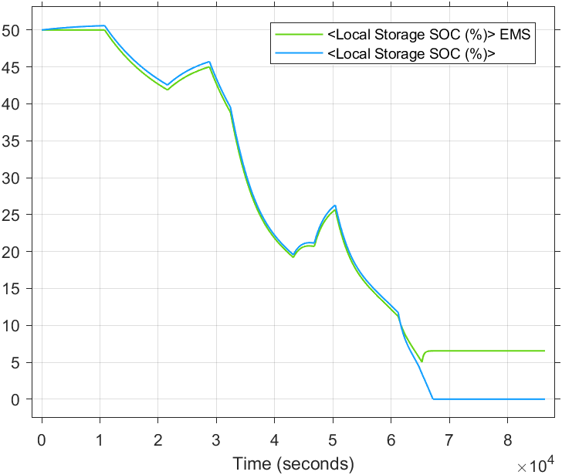

Figure .: Local storage SoC EMS v non-EMS

Load profile 4 demonstrates the load shedding feature of the EMS which reduces supply capacity to extend battery usage.

Figure .: Non-EMS Supply capacity v load demand

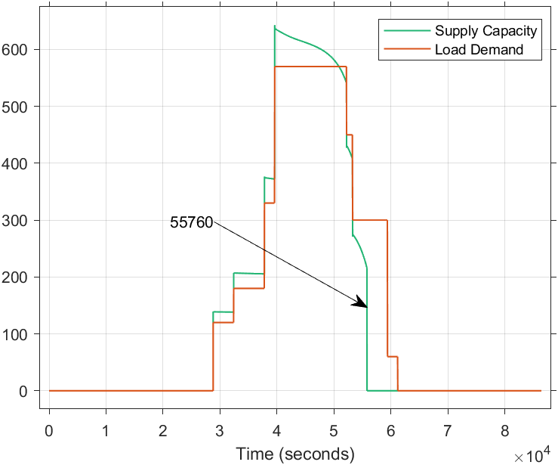

Figure .: EMS Supply capacity v load demand

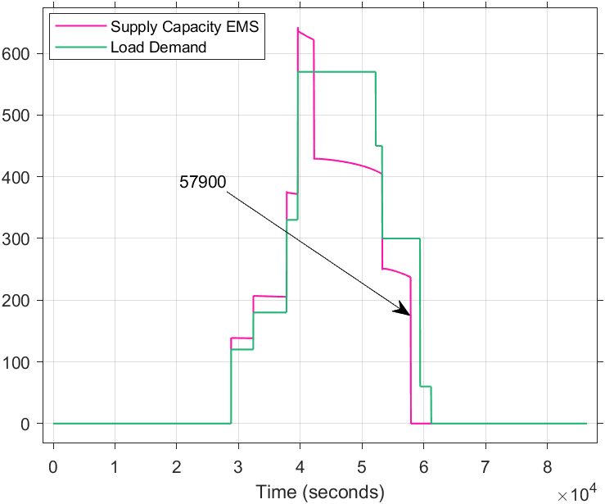

The time differences between the systems are shown in Figure 4.36 and Figure 4.37 Figure 4.39 . As a result of load shedding, EMS gains a 2140 seconds before dropping supply to zero.

Figure .: Solar Farm SoC EMS v non-EMS

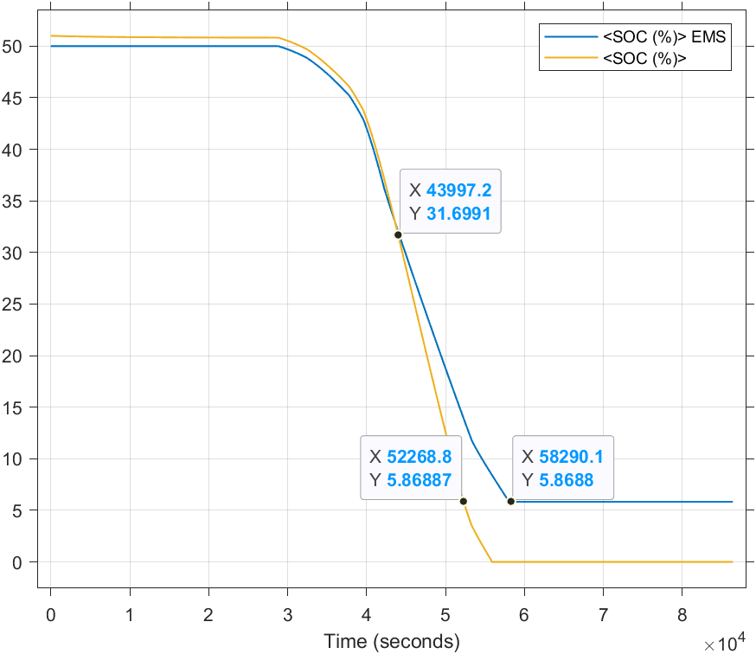

Figure .: Local storage SoC EMS v non-EMS

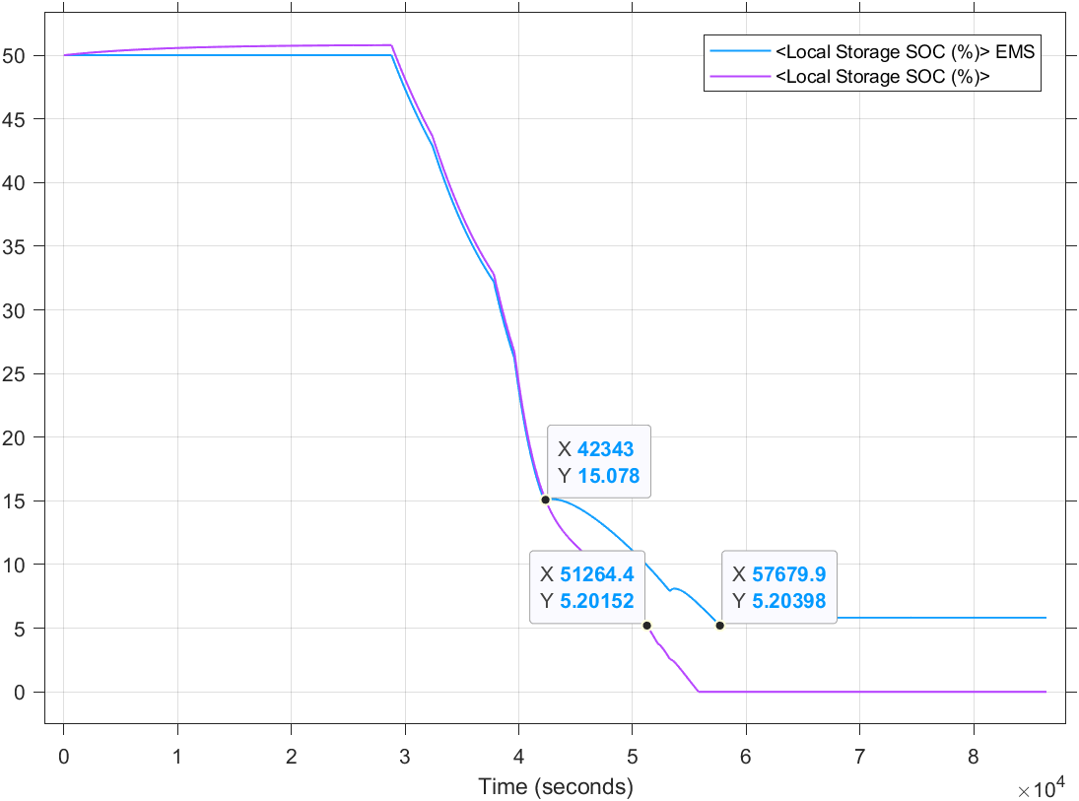

The results of the improvement in the Energy Management System due to the implementation of load shedding are shown in Figure 4.38 and Figure 4.39. The rate of discharge of SoC, or discharge rate, for the local energy storage has been reduced to -2.30% per hour, compared to -3.96% per hour in the non-EMS system. Similarly, for the solar farm, the discharge rate has been reduced to -6.5% per hour, compared to 11% per hour in the non-EMS system.

### Case Study 4

Table 4.6: Scenario 4: Model setup parameters

|  |  |
| --- | --- |
| Irradiance profile | See Figure 4.2 |
| Battery size and capacity | Nominal voltage: **0** V DC  Capacity: **0**Ah  Initial SOC: **0**% |
| Load Size | Minimum: 60 (W)  Maximum: 570 (W) |
| PV module | Maximum power: **0** (W)  Vmp: **0** (V)  Imp: **0** (A) |
| Load profiles used | Case study 1: Load profile 1(Figure 4.4)  Case study 2: Load profile 2(Figure 4.5)  Case study 3: Load profile 3(Figure 4.7)  Case study 4: Load profile 4(Figure 4.6) |

Case study 4 presents a unit which has no energy storage system or PV panel. It is an entirely grid-dependent unit which relies on solar farm and excess power from other units. The supply capacity response for this configuration is shown in Figure 4.40 and Figure 4.41. The EMS has control measures to prevent total grid collapse by completely disabling loads, Figure 4.41. shows supply capacity being dropped to zero. The discontinuity on the non-EMS system in Figure 4.40 is a result of Matlab simulation being unable to simulate a grid collapse condition due to hardware limitations.

Figure .: non-EMS Supply capacity v load demand

Figure .: EMS Supply capacity v load demand

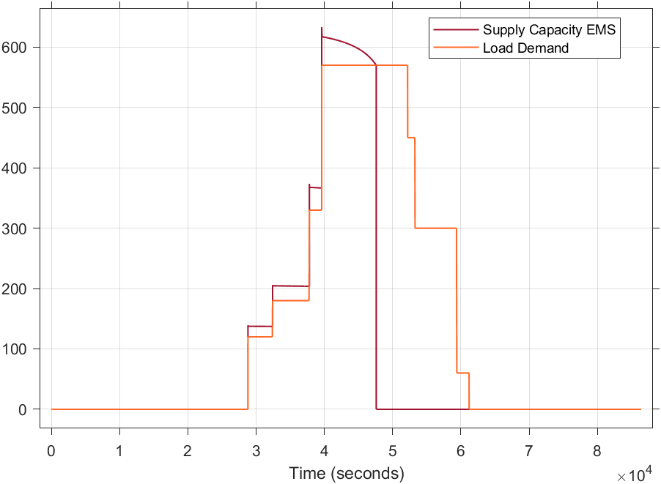

## Lab-Developed Working System Setup

A functional system was developed in the lab, as depicted in Figure 4.42. Solar panels are mounted outside. The computers use Matlab Simulink to receive external data, process it, and display the system's real-time operation, The DC loads consist of car headlamps with power ratings between 60W and 120W. These lamps are connected in various combinations to simulate household loads, including cell phone charging stations. Additionally, one of the units uses a DC fridge as a load.

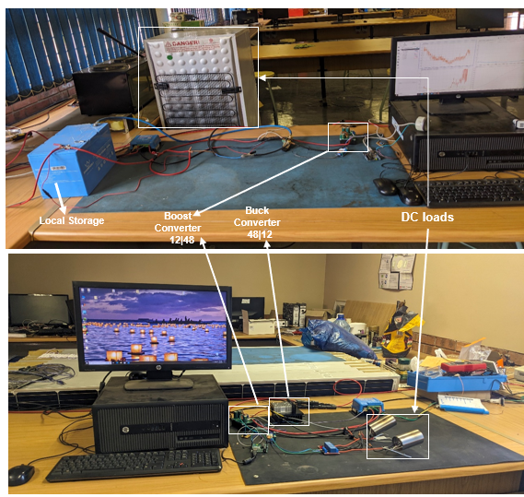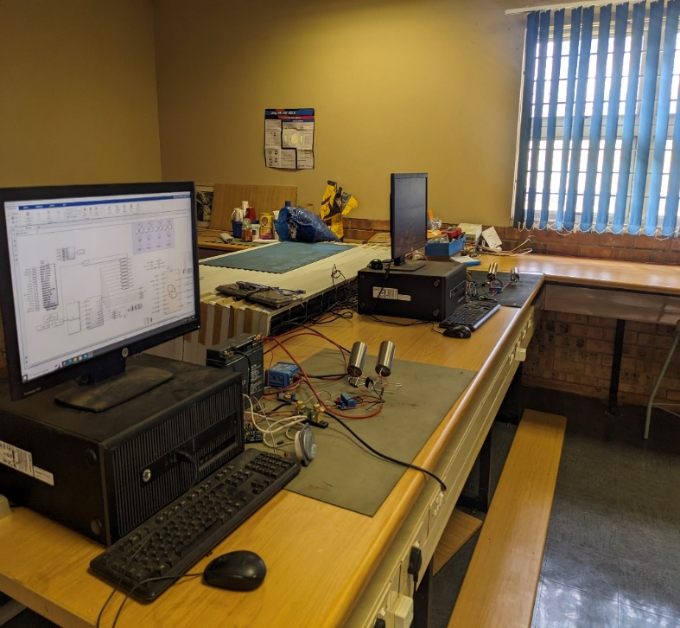

Figure 4.42: Lab setup of four units DC microgrid

The data obtained from the models was collected for a period of 5 days in which some loads were switched at random intervals to simulate everyday appliances usages. The purpose of this data collection was to analyse the behaviour of electrical loads in a typical household setting. By randomly switching loads, the object was to create a realistic representation of appliance usage patterns, including peak usage times and energy consumption fluctuations. This approach allows for a more accurate assessment of the models' performance in managing energy demand.



### Lab results - Unit 1

Table 4.7: Unit1 - Laboratory setup parameters

|  |  |
| --- | --- |
| Battery size and capacity | Nominal voltage: 12 V DC  Capacity: 100Ah |
| Load Size | Minimum: 60 (W)  Maximum: 520 (W) |
| PV module | Maximum power: 330(W).  Vmp: 36.92(V)  Imp: 8.14(A) |

The five-day supply capacity v load demand shown in Figure 4.43 indicates a well-managed load demand, power saving mode is enabled whenever demand exceeds supply.

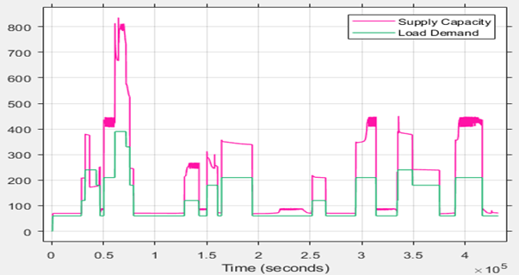

Figure 4.43: Unit 1 5-day Supply v Load Demand

This system ensures efficient energy use by dynamically adjusting to consumption patterns. When demand surpasses supply, power saving measures are activated to prevent overloading and maintain stability. This approach not only optimizes energy utilization but also extends the lifespan of the battery storage by preventing excessive discharge.

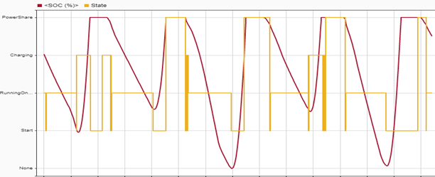

Figure 4.44: five-day Solar farm SoC v Operation state.

The power share feature is illustrated in Figure 4.44. Power sharing is enabled when local battery storage reaches full capacity. The grid benefits from the unit as its PV panels are used to rapidly recharge the battery storage and/or supply connected loads.

### Lab results - Unit 2

Table 4.8 : Unit2 - Laboratory setup parameters

|  |  |
| --- | --- |
| Battery size and capacity | Nominal voltage: 12 V DC  Capacity: 17Ah |
| Load Size | Minimum: 60 (W)  Maximum: 520 (W) |
| PV module | None |

Unit 2 relies on the grid to charge its battery storage, as illustrated in Figure 4.45. The control system maintains grid stability by disconnecting loads when necessary. Due to the limited battery size, the supply sometimes fails to meet demand, causing the unit to be unable to fully power appliances in certain situations. However, the control system prevents the batteries from completely discharging, thereby protecting their health.

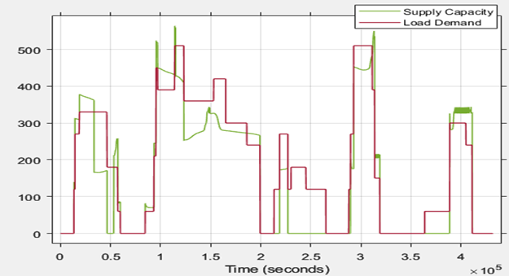

Figure 4.45 Unit 2 Supply Capacity v Load Demand.

Prioritizing grid usage over local storage allows local loads to operate for longer periods. However, due to the limited battery capacity, the local state of charge drops quickly, necessitating the control system to switch to grid usage. The comparison between solar farm and local storage SOCs is shown below.

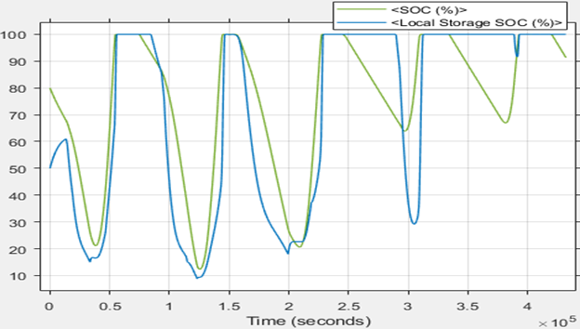

Figure 4.46 Unit 2 Solar Farm v local storage SoC.

### Lab results - Unit 3

Table 4.9 : Unit3 - Laboratory setup parameters

|  |  |
| --- | --- |
| Battery size and capacity | None |
| Load Size | Minimum: 60 (W)  Maximum: 400 (W) |
| PV module | Maximum power: 330(W).  Vmp: 36.92(V)  Imp: 8.14(A) |

Unit 3 is highly dependent on the grid from sunset to sunrise. During this period, loads are significantly limited to conserve power.

This dependency highlights the importance of efficient energy management in off-peak hours. By restricting load usage, the system ensures that essential functions can continue without overloading the grid.

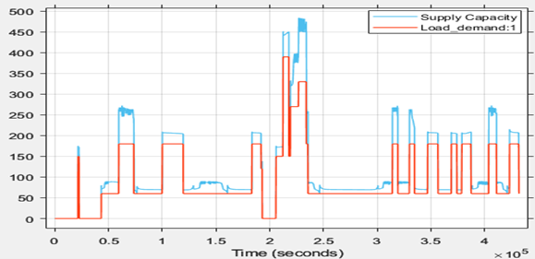

Figure 4.47 Unit 3 Supply Capacity v Load Demand.

### Lab results - Unit 4

Table 4.10 Unit 4 - Laboratory setup parameters

|  |  |
| --- | --- |
| Battery size and capacity | None |
| Load Size | Minimum: 60 (W)  Maximum: 400 (W) |
| PV module | None |

Unit 4 is entirely dependent on the grid, making it highly sensitive to any major changes in the grid system. This unit underscores the critical importance of maintaining grid stability. It also demonstrates the necessity of self-management; without an Energy Management System to control local loads and the absence of local storage and generation capacity, this unit could potentially destabilize the grid.

Figure . Unit 4 Supply Capacity v Load Demand.

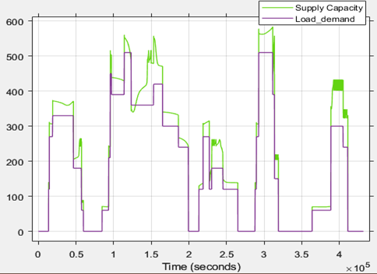

The system optimizes energy use by adjusting to consumption patterns, activating power-saving measures when demand exceeds supply, and extending battery lifespan by preventing over-discharge. Power sharing from solar panels occurs when local battery storage is full, benefiting the grid. In Unit 2, which relies on the grid for charging due to limited battery capacity and no PV module, the control system ensures stability by disconnecting loads as needed and preventing complete battery discharge. Grid usage is prioritized to extend operation times, though the local state of charge drops quickly, requiring a switch to grid power.

The laboratory system's responses are similar to the Matlab simulation since the unit's EMS remains consistent; any variations are due to differences in battery capacity and load.

Chapter 5

# CONCLUSION AND RECOMMENDATIONS

This dissertation has explored the impact of renewable energy integration on DC grid stability and efficiency. Through a comprehensive analysis of residential energy management and control systems, this research has demonstrated that such systems can significantly enhance the utilization of renewable resources while maintaining grid stability.

## Key findings:

### ****Efficiency in Energy Utilisation****

The EMS enhances system efficiency by adapting to real-time consumption patterns, preventing overloading and excessive battery discharge. This optimization not only improves energy usage but also extends battery life. The system of systems architecture supports this by ensuring each unit operates independently, prioritising local resources while sharing any excess energy and storage when not in use.

### ****Power Sharing****

The power share feature, detailed in Figure 4.44 , allows for surplus energy from fully charged local battery storage to be redirected to the grid. This not only aids in rapid recharging but also in supplying connected loads, enhancing overall energy distribution efficiency. Power sharing is also enabled for systems with PV panels during daylight when they are producing power and there's minimal load connected to the system.

Figure 4.8.12 shows the comparison of the State of Charge (SoC) and state transition charts for Case Study 2. The EMS enables power sharing when there is sufficient power available to charge the battery while also supplying local loads. The duration of this power sharing can impact systems that rely solely on the grid for their energy storage.

### ****Grid Dependence and Battery Capacity****

The laboratory results for Unit 2, as outlined in Table 10, reveal that grid reliance for battery charging is crucial due to limited battery capacity and lack of PV modules.

This research has utilised PV panels for energy generation and lithium batteries for storage, resulting in a high reliance on battery capacity since PV panels do not produce power from sunset to sunrise. To stabilise the grid, additional energy storage is essential. A diverse range of energy sources and storage solutions enhances grid stability and reliability.

### ****Comparative analysis of Supply and Demand****

Figure 4.28 illustrates the comparative performance of supply capacity versus load demand. Prioritising grid usage over local storage allows for extended operation of local loads, although the rapid decrease in the state of charge necessitates frequent switching to grid power.

From the grid’s perspective, the connected systems act as both energy sources and loads. These systems manage themselves according to the defined rules discussed in Chapter 3, which prevent total grid collapse. Supply and demand analyses are conducted based on system type. The analyses for all systems, as discussed in Chapter 4, highlight the importance of systems managing themselves during supply/demand imbalances. The 5-day SoC vs. Operating State of Unit 1 lab results, showcased in Figure 4.44, explain the system's responses in various supply and demand situations.

This research contributes to the field by providing empirical evidence supporting the efficiency and reliability of REMCS in renewable energy systems. Future work could focus on predictive artificial intelligence (AI) algorithms that can be implemented for improve REMCS and anticipate supply and demand effectively. Additional renewable energy sources and storage technologies may be incorporated into the grid to further stabilise the grid and reduce dependence on any single energy source.

The introduction of USB Type-C and the Power Delivery (PD) standard has enabled the development of new DC home appliances, removing the need for inverters and transformers. DC microgrids provide an efficient solution for connecting these appliances to distributed energy sources and storage systems.

The Findings indicates a potential future of DC microgrids for home electrification. a system of systems approach is providing a clear solution of how these systems interact with each other.

References

|  |  |
| --- | --- |
| [1] | L. E. Zubieta, "Power Management and Optimization Concept for DC Microgrids," ARDA Power Inc., Oakville, Ontario, Canada, 2015. |
| [2] | X. Jianfang, Z. Tianyang, H. Koh Leong and P. Wang, "Smart Energy Hub - Modularized Hybrid AC/DC Microgrid: System Design and Deployment," Energy Research Institute, Nanyang, Singapore, 2017. |
| [3] | K. Dinesh and Z. Firuz, "DC Microgrid Technology: System Architectures,AC Grid Interfaces, Grounding Schemes, Power Quality, Communication Networks, Applications, and Standardizations Aspects," *Special Section On Power Quality And Harmonics Issues Of Future And Smart Grids,* pp. 36,122, 2017. |
| [4] | E. Rodriguez-Diaz, E. J. Palacios-Garcia, A. Anvari-Moghaddam and V. Juan C, "Real-Time Energy Management System for a Hybrid AC/DC Residential Microgrid," in *IEEE*, Spain, 2017. |
| [5] | C. Sulzberger, IEEE Power & Energy for Electric Power Proffesionals, New York: Power & Energy Society, 2013. |
| [6] | K. S. Rajesh, S. S. Dash, R. Rajagopal and R. Sridhar, "A review on control of ac microgrid," *Renewable and Sustainable Energy Reviews,* vol. 71, no. 1364-0321, pp. 814-819, 2017. |
| [7] | S. Tapan and A. A. Zeeshan, "An Overview of Intelligent Energy Management System for DC Microgrid : System and Communication Architecture and Application in Power Distribution System," *International Conference on Industrial and Information Systems (ICIIS),* vol. 13, pp. 339 - 342, 2018. |
| [8] | M. Melfi and S. D. Umans, "DC Machines," *Encyclopedia of Electrical and Electronic Power Engineering,* vol. 1, pp. 264 - 279, 2023. |
| [9] | M. Keerthana, U. G and S. U, "A study of a solar PV and wind-based residential DC NanoGrid with dual," *International Journal of Electrical Power and Energy Systems energy storage system under islanded/ interconnected/grid-tied modes,* no. 143, 2022. |
| [10] | A. Osama, S. Reem, B.-A. Abdullah, A. Mohammad, A.-M. Mohammad and B. NoorAldeen, "Experimental comparison between Monocrystalline, Polycrystalline, and Thin-film solar systems under sunny climatic conditions," *Energy Reports,* vol. 8, pp. 218-230, 2022. |
| [11] | Q. Ma, H. Fang and M. Zhang, "Theoretical analysis and design optimization of thermoelectric generator," *Applied Thermal Engineering,* vol. 127, pp. 758-764, 2017. |
| [12] | P. K and D. S. Arul, "Performance analysis of a 3 MWp grid connected solar photovoltaic power plant in India," *Energy for Sustainable Development,* vol. 17, pp. 615-625, 2013. |
| [13] | B. Marion, J. Adelstein, K. Boyle, H. Hayden, B. Hammond, T. Fletcher, B. Canada, D. Narang, D. Shugar, H. Wenger, A. Kimber, L. Mitchell, R. G and T. Townsend, "Performance Parameters for Grid-Connected PV Systems," in *National Renewable Energy Laboratory*, Colorado, 2005. |
| [14] | Z. Tabaie and A. Omidvar, "Human body heat-driven thermoelectric generators as a sustainable power supply for wearable electronic devices: Recent advances, challenges, and future perspective," *Heliyon,* vol. 9, p. e14707, 2023. |
| [15] | L. Azadani, "Vertical axis wind turbines in cluster configurations," *Ocean Engineering,* vol. 272, p. 113855, 2023. |
| [16] | Nandini, K K; Jayalakshmi, N S;Vinay Kumar Jadoun, "An overview of DC Microgrid with DC distribution system for DC load," *Materials Today,* Vols. Volume 51,, no. 1, pp. 635-639, 2022. |
| [17] | C. Katar and C. P. Uzunoğlu, "A comparative study on AC/DC analysis of an operational low voltage distribution system," *International Journal of Applied Power Engineering (IJAPE),* vol. 10, no. 3, pp. 193-206, 2021. |
| [18] | A. Joseph and M. Shahidehpour, "Battery storage systems in electric power systems," *2006 IEEE Power Engineering Society General Meeting,* pp. 8-pp, 2006. |
| [19] | M. Aneke and M. Wang, "Energy storage technologies and real life applications – A state of the art review," in *Applied Energy*, Hull, 2016. |
| [20] | S. O. Amrouche, D. Rekioua, T. Rekioua and S. Bacha, "Overview of energy storage in renewable energy systems," *International Journal of Hydrogen Energy,* pp. 20914 - 20927, 2016. |
| [21] | A. Raza, Y. Chen, M. Li, S. I. Abouzeid and E. H. Abdelhameed, "Feasibility and optimal size analysis of off grid hybrid AC-DC microgrid system: Case study of El Kharga Oasis, Egypt,," *Journal of Energy Storage,* Vols. Volume 97, Part A, p. 112721, 2024. |
| [22] | Z. Chen, K. Wang, Z. Li and T. Zheng, "A Review on Control Strategies of AC/DC Micro Grid," IEEE Xplore, Shaanxi Province, P.R. China, 2017. |
| [23] | N. B and C. K, "DC Local Power Distribution: Technology,Deployment, and Pathways to Success," *IEEE Electrification Magazine,* vol. 4, no. 2, pp. 29-36, 2016. |
| [24] | M. AA, M. Rashed, X. Lang, J. Atkin, S. Yeoh and S. Bozhko, "Droop control design to minimize losses in DC microgrid for more electric aircraft," in *Electric Power Systems Research 199*, 2001. |
| [25] | R. F. Bastos, C. R. Aguiar, A. Balogh, Z. Sütő and R. Q. Machado, "Power-sharing for dc microgrid with composite storage devices and voltage restoration without communication," *Electrical Power and Energy Systems,* vol. 138, no. 107928, 2022. |
| [26] | V. A. Prabhala, B. P. Baddipadiga and M. Ferdowsi, "An Overview of Direct Current Distribution System," *Energies,* pp. 7-14, 2018. |
| [27] | M. Beus, F. Banis, H. Pandžić and N. K. Poulsen, "Three-level hierarchical microgrid control—model development and laboratory implementation," in *Electric Power Systems Research*, 2020. |
| [28] | D. Burmester, R. Rayudu, W. Seah and D. Akinyele, "A Review of Nanogrid Topologies and Technologies," *Renewable and Sustainable Energy Reviews,* no. 67, pp. 760-775, 2017. |
| [29] | P. Surya, M. Sukumar and P. Narayana Prasad, "Coordinated Control of a Grid Connected DC MicroGrid with Multiple Renewable Sources," in *Asia-P acific P ower and Energy Conference*, Xi'an, 2016. |
| [30] | G. B. Andreadis, K. KD and N. K, "Review of Agent–Based Systems in the Manufacturing Section," *Universal Journal of Mechanical Engineering,* vol. 2, no. 2, pp. 55-59, 2014. |
| [31] | L. Yuto, M. J. Hossain, S. Javaid and Y. Tan, "Study of Home Energy Management System for DC-based Nanogrid," in *IEEE International Conference on Consumer Electronics*, Taiwan, 2020. |
| [32] | M. R. K. Durga, K. M. Mahesh and S. Y. Ram, "Dynamic Energy Management in DC Microgrid using Composite Energy Storage System," in *IEEE International Conference on Power Electronics, Smart Grid and Renewable Energy*, 2020. |
| [33] | L. Manoj and S. Ponnaluri, "A Review of DC Microgrid Operation and Control," in *International Renewable Energy Congress*, Mumbai, India, 2015. |
| [34] | X. Fang, S. Misra, G. Xue and D. Yang, "Smart Grid—The New and Improved Power Grid: A Survey," *IEEE Commun,* pp. 944-980, 2012. |
| [35] | A. Ahmad, F. Mehdi, S. Pourya and C. H. Dagli, "Modeling and Simulation of Microgrid," in *Complex Adaptive Systems Conference with Theme: Engineering Cyber Physical Systems*, Chicago, 2017. |
| [36] | H. DJ, "AC Versus DC Distribution SystemsDid We Get it Right?," in *2007 IEEE Power Engineering Society General Meeting*, Tampa, FL, USA, 2007. |
| [37] | Y. S. Bhavsar, P. V. Joshi and S. M. Akolkar, "Energy Management in DC Microgrid," in *International Conference on Energy Systems and Applications (ICESA 2015)*, India, 2015. |
| [38] | M. Starke, L. M. Tolbert and B. Ozpineci, "AC vs. DC Distribution:A Loss Comparison," in *Transmission and Distribution Conference and Exposition*, Chicago, IL, USA, 2008. |
| [39] | K. Techakittiroj and V. Wongpaibool, "Co-existance between AC-Distribution and DC-Distribution: In the View of Appliances," in *Second International Conference on Computer and Electrical Engineering*, Dubai, United Arab Emirates, 2009 . |
| [40] | A. Vosloo, "Agent-Based Energy Management Systems for The Remote community microgrid," Cape Peninsula University of Technology, Bellville Campus, 2015. |
| [41] | L. Fulong, C. Claudio and L. Zhengyu, "Energy Management System for DC Microgrids Considering Battery Degradation," in *IEEE explore*, Leicestershire, United Kingdom; Waterloo, Ontario, Canada, 2020. |
| [42] | H. Ligang, T. Xianghua and S. Xiongjie, "Research on Control Method of Energy Storage Interface for DC Micro-grid," in *Energy Internet and Energy System Integration*, Changsha, 2019. |
| [43] | B. Muhammad, M. D, R. Moreno, A. A. Kelum and C. Gamage, "Artificial intelligence-enabled probabilistic load demand scheduling with dynamic pricing involving renewable resource," *Energy Reports,* vol. 8, pp. 14034 - 14037, 2022. |
| [44] | C. Y. Chun, J. Baek, G.-S. Seo, B. Cho, I. K. C. Jonghoon Kim and S. Lee, "Current sensor-less state-of-charge estimation algorithm for lithium-ion batteries utilizing filtered terminal voltage," *Journal of Power Sources,* vol. 273, pp. 255-263, 2015. |
| [45] | Eskom, "Solar irradiance data," Eskom holdings ltd, 12 2020. [Online]. Available: https://www.eskom.co.za/AboutElectricity/RenewableEnergy/Documents/SolarData_site3fullsetTellerie.xls. [Accessed 3 12 2020]. |
| [46] | M. K, B. muhammad and M. M, "DC Home Appliances for DC Distribution System," *Mehran University Research Journal of Engineering & Technology,* vol. 36, no. 4, p. 840, 2017. |
| [47] | B. Mota, P. Faria and Z. Vale, "Residential load shifting in demand response events for bill reduction using a genetic algorithm," *Energy,* vol. 260, no. 1, 2022. |
| [48] | Housing Development Agency, "Housing Development Agency," 14 February 2020. [Online]. Available: http://www.thehda.co.za/uploads/files/HDA_Informal_settlements_status_South_Africa.pdf. |
| [49] | M. H. Spencer Turner, "Human Response to electricity: A Literature review," Columbus, Ohio: The Aviation Medicine Research Laboratory, Ohio, 1972. |
| [50] | NASA Langley Research Center Atmospheric Science Data Center, "Johannesburg, South Africa - Solar Energy and Surface Meteorology," Gaisma, 2002. [Online]. Available: https://www.gaisma.com/en/location/johannesburg.html.. [Accessed 17 February 2020]. |
| [51] | A. Vosloo, "Agent-based Energy Management System for Remote Community Microgrid," Cape Peninsula University of Technology, Cape Town, 2015. |
| [52] | M.-H. Carlos, H.-S. Fernando and F.-B. Manuel, "Practical method to estimate energy potential generated by photovoltaic cells: practice case at Merida City," *Energy Procedia,* vol. 57, no. 245, pp. 35-37, 2014. |
| [53] | L. Manoj and P. Srinivas, "An Overview of DC Microgrid Operation and Control," *International Renewable Energy Congress (IREC),* vol. 6, pp. 1-5, 2015. |
| [54] | E. Christoph, H. Rodolfo, S. Thomas, G. Dominique, R. Dominique and P.-O. Moix, "Modular ICT based Energy Management System for a LVDC-microgrid with local PV production andintegrated electrochemical storage," Institute for System Engineering, Sion, Switzerland. |
| [55] | J. Hu, Y. Shan, J. M. Guerrero, A. Ioinovici, K. W. Chan and J. Rodriguez, "Model predictive control of microgrids – An overview," *Renewable and Sustainable Energy Reviews,* vol. 136, no. 110422, 2021. |
| [56] | S. John and R. Simon D, "DC-Bus Signaling: A Distributed Control Strategy for a Hybrid Renewable Nanogrid," *IEEE TRANSACTIONS ONINDUSTRIALELECTRONICS,* vol. 53, no. 5, pp. 1456-1460, 2006. |
| [57] | A. Peter, F. Adam and V. Laura, "Microgrid Analysis and Case Studies Report," California Energy Commission, California , 2018. |
| [58] | R. S. S. A. N. Z. Salem Batiyah, "An MPC-based power management of standalone DC microgrid with energy storage," *International Journal of Electrical Power & Energy Systems,* vol. 120, no. 105949, 2020. |
| [59] | B. J, J. O and H. V, "Optimal Wireless Technology Selection Approach for Sustainable Indian Smart Grid," *Strategic Planning for Energy and the Environment,* vol. 40, no. 3, p. 255–278, 2021. |
| [60] | V. A. Prabhala, B. P. Baddipadiga and M. Ferdowsi, "An Overview of Direct Current Distribution System," *Energies,* vol. 11, no. 2463, pp. 7-14, 2018. |
| [61] | J.-L. Zeng, X. Liu, C.-Q. Su, Y.-P. Wang and X. Xiong, "Numerical investigation of a geothermal thermoelectric generator using gravity heat pipe structure," *International Conference on Power and Electrical Engineering (ICPEE),* vol. 3, pp. 21-31, 2022. |
| [62] | S. M. Abu, M. A. Hannan, M. S. H. Lipu, M. Mannan, P. J. Ker, M. Hossain and T. I. Mahlia, "State of the art of lithium-ion battery material potentials: An analytical evaluations, issues and future research directions,," *Journal of Cleaner Production,* p. 2023, 394. |
| [63] | P. Pal, V. Mukherjee, P. Kumar and M. Makhatha, "Viability analysis of direct current (DC) standalone hybrid photovoltaic (PV)/ hydrogen fuel cell (HFC) energy system: A techno-economic approach," *materialstoday,* vol. 39, no. 4, pp. 187-1812, 2021. |
| [64] | C. Duenas, J. Santos, A. L. AM, Mezher, J. C. Barrera, J. Meng and C. G. E, "RPL+: An improved parent selection strategy for RPL," *ACM International Symposium on Performance Evaluation of Wireless Ad Hoc, Sensor, & Ubiquitous Networks,* vol. 19, pp. 75-82, 2022. |
| [65] | W. Shi, N. Li, X. Xie, C. CC and R. Gadh, "Optimal Residential Demand Response in Distribution Networks," *IEEE J. Sel. Areas Commun.,* vol. 32, p. 1441–1450., 2014. |
| [66] | E.-K. Lee, W. Shi, R. Gadh and W. Kim, "Design and Implementation of a Microgrid Energy," *Sustainability,* vol. 8, pp. 2-4, 2016. |
| [67] | L. J, L. Llopis and F. R, "A machine learning based Distributed Congestion Control Protocol for multi-hop wireless networks," *Computer Networks,* vol. 231, p. 109813, 2023. |
| [68] | K. S. Schmitz, "Chapter 1 - Philosophy of Science," in *Physical Chemistry*, Elsevier, 2018, pp. 183-367. |